5 WorkshopAR – Implementation Process

The previous chapter detailed the architectural design of WorkshopAR, that is, the main ideas and decisions taken to fulfil the goals proposed for the software development and the efforts done to align the technical aspects of the project with the educational goals present in the research. The chapter also identified key components of the development process to follow and proposed an overall plan for the implementation of the software.

This chapter will continue the technical analysis of the project, this time with a focus on the final implementation process and the important details that create opportunities for discussion. This analysis will highlight the research done to identify and propose a suitable interaction design that takes into consideration the context around WorkshopAR, the evolving tendencies in the implementation of AR experiences and all the information regarding good and bad practices that had been found in the literature.

It will also be an opportunity to compare the plans and ideas proposed in the architectural design against the actual implementation of the software, identify the reasoning behind such changes and how the context and circumstances of the development shaped the final product.

Finally, this chapter will detail the software development process used. The process proposed and implemented two iterations of development which emphasized testing procedures and early validations. There was also an important effort to integrate the development of the tool with the case study and evolved with the particularities of the course and the educational needs of the final users.

Chapter 3 detailed the reasoning behind the chosen development methodology, explaining how an iterative approach allowed for experimentation and flexibility, and that better accommodated the constraint imposed in time and resources to facilitate development following a “just-enough” approach to architecture, design and implementation.

As a result, WorkshopAR undertook a development process in two iteration cycles which derived in the testing and deployment of a prototype used for observation and data gathering. Both cycles were structured around a design phase, implementation and quick adjustments. In between iterations it was possible to allocate some time to data analysis and planification for the nest iteration cycle.

Iteration 1 focused on building and testing the functional AR technology behind WorkshopAR: the shared AR space and the fundamental AR interactions. The overall goal was to explore the main use cycle of creating a room, starting a session with other users and share visualizations of different digital objects.

The in between testing and analysis was used to better aligning WorkshopAR to the particularities of the Industry Project Course, as well as incorporating key observations provided by initial test users.

Iteration 2 focused on providing the needed functionalities to fulfil the uses cases identified in the architectural design process, those that provided most value to the users and the research.

A final analysis of the results was done to identify possible solutions to the issues and ideas generated from the data gathering, both at an implementation and design level. There is also a discussion of possible future steps for WorkshopAR, of how the software can evolve and the lessons learned for future or related scenarios.

The following sections will then describe this implementation process and provide a form of post-mortem of the activity to promote discussion and analysis of the results. Section 5.1 will first detail the research done as part of the interaction design of WorkshopAR, research that informed the approach that the software was going to take in relation to AR technologies and how to implement a set of interactions for the collaborative and multi-platform tasks present in the context of development. Section 5.2 will describe and show the results of the development process, organizing the analysis around the two iteration cycles described previously. Section 5.3 will act as a final analysis and conclusion of the results of the implementation process, the development of WorkshopAR and for the technical section of the research in general.

# 5.1 Interaction Design

An important effort in the construction of WorkshopAR was put in the design of the interactive elements at the core of the experience. The interactions that received the most attention during the design process can be classified in three:

* Interactions with digital objects in the AR spaced created for the room.
* Social interactions between participants in relation to group management and the objective activities of the course.
* The controls of the tool itself, the individual components and the flow of the work session.

These interactions were prioritised because they represent the tools that WorkshopAR uses to promote the behaviours and ideas around collaboration at the core of the objectives and design of the project. It is especially important in the design of social interactions and the structure that is being proposed for the work process but without interfering too much in a negative way or hindering the academical work of the students. In a similar light, the project also offers the opportunity to explore solutions to a variety of interaction problems associated with the use of AR in mobile devices such as:

* Simultaneously interact with digital objects that are shared with other users.
* Organize and select information.
* Use and understand social cues from other users.
* Plan and organize tasks for a common objective.
* Jump from using the AR application to any other external activity and vice versa.

The following section will explore all these aspects of the interaction design in two main approaches. The first one will focus on general AR design and will detail the research done to understand how to use mobile AR devices in social and collaborative activities, and the user-guided design followed to identify the best approach to the overall AR interactions needed for the implementation of WorkshopAR.

The second part of the section will detail the decisions taken for the top-down interactions implemented for WorkshopAR, that is, the final implementation and user experience for activities related to create a work session, interact with the digital objects in the room and structure the collaborative activities of the group using WorkshopAR.

## 5.1.1 Collaborative interactions in AR

The use of AR technology in the core of a software solution has moved beyond the speculative stage and is no longer confined to pure research. Successful implementations of AR in everyday usage and production, such as those reported by Kowalewski et al. (2017), demonstrate its practical applications. Furthermore, the availability of ready-to-use software like Manifest (Manifest AR Work Instruction Platform, 2022) and the accessibility offered by end-user products like the Meta Quest 3 (Meta, n.d.) highlight the need to consider any development within the broad spectrum of mixed realities as a product intended for the general consumer. This is why the development of WorkshopAR, although envisioned as a research prototype, aims for an implementation guided by a user-centred, human-centred design approach, as explained in chapter 3.

For a human-centred approach it is important to considers the requirements that are directly related to interactions of the end user with the core utility of the product and the

context in which it happens (Boy, 2017). This general design goal is highly relevant for WorkshopAR if seen as a product introducing AR technology to the collaborative education context. AR technology remains relatively new to most consumers and most of them have little or no contact with it in their daily routines (Chang, Kuo, & Du, 2023). Consequently, users have not yet developed a consistent digital literacy around these and similar technologies. Is equally uncommon, even for experience users, to have any form of expectations about the behaviour and allowed interactions of any particular development. Even when an application is deployed in more recognizable platforms, like a smartphone, the affordances and interaction methods that the users are accustomed to may not be the same or may be entirely absent.

Several efforts have been made to create a shared language for developers to use

in the interaction design of their applications, and to solve common problems with

consistent approaches. Research studies such as those conducted by Piumsomboon, Clark, Billinghurst, and Cockburn (2013) and Wobbrock, Morris, and Wilson (2009) have formulated and compiled an array of gestures tailored to various forms of Augmented Reality and

Mixed Reality (MR) interactions. These proposed sets of gestures encompass a broad

spectrum of general interactions, ranging from basic object selections and manipulation

to complex tasks like file browsing and content editing. However, these gestures are designed under the assumption of single-user interactions.

While some interactions may coincide with those found in single-user applications, others are unique to multi-user settings. Moreover, it is important to note that collaboration is not an inherent aspect of multi-user scenarios. Various forms of social interactions, facilitated by technology, can introduce their own unique challenges and characteristics. The objective of the research described in this section is to explore the particularities of collaborative interaction in AR. Using the same user-driven methodology proposed in the studies cited

previously, the aim is to identify common tasks executed in a collaborative setting using different forms of AR technology. Based on that, the end result is a proposed set of gestures that capture the most natural interactions that users perform and tend to converge to. The results were directly used as a design guideline for the interaction design of WorkshopAR, highlighting effective strategies to tackle particular tasks related to the use of AR in the collaborative scenario and the use of mobile devices as the main focus for deployment.

### 5.1.1.1 Research Methodology

The interaction design process was guided by a three-step procedure: 1.) Identification and selection of tasks, 2.) Data collection from participants proposing interactions for the identified tasks, and 3.) Analysis of the collected data to identify convergent approaches, recurrent issues, and common behaviours.

In total, 24 different participants were interviewed with a median age of 41 and standard

deviation of 11. Of the participants, 66% were women while 34% were men. In terms of demographics, 20% of the participants were university students with careers mostly in design and computer science. The remaining participants were professionals in different fields like IT, medicine, and administration.

Two different scenarios were designed for the test. In Scenario 1, participants were equipped with a smartphone, which they were required to hold in one hand, leaving

the other one free to interact during each task. Scenario 2 involved the use of a Microsoft HoloLens headset, which afforded the participants the freedom to use both hands. Figure 1 shows examples of each scenario.

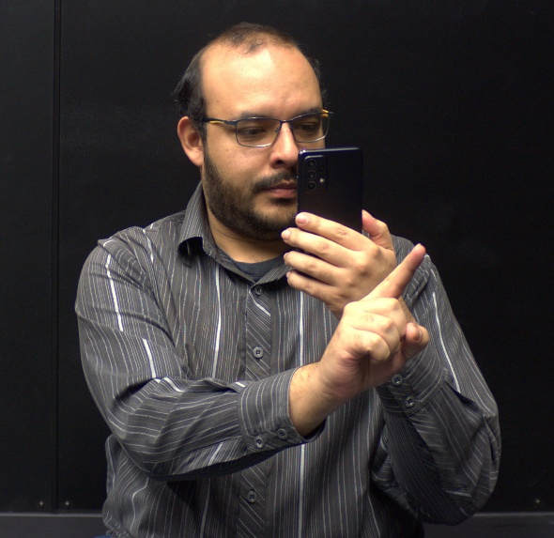

Figure 1 Setups for Scenario 1 (using a smartphone) and Scenario 2 (using a HoloLens)

Both scenarios facilitated distinct modes of interaction, which were anticipated to influence the participants’ thought processes and instinctive responses for each task. It was hypothesized that:

* Scenario 1 would prompt individuals to interact with the screen rather than the free hand.
* Scenario 2 would prompt more air gestures.
* Each scenario would converge to its own set of gestures rather than both converging to the same general set.

It is also important to remark that at this point in the design of the software it was not clear if WorkshopAR was going to be implemented with full cross-platform compatibility in mind, and it was also important to identify how users proposed gestures for the same task in different scenarios, if they diverged enough that would be necessary to create to different input systems of if there was some form of convergent method that could be used or expanded upon.

As noted in previous sections, Piumsomboon et al. (2013) proposed a set of tasks related to the most common activities a person would need to perform in an AR application. These tasks are related to selection, manipulation, and transformation of digital objects. Nowadays these actions have become common and expected in any environment that requires 3D interactions, with the particularity that these tasks are all related to single-user experiences. Based on ideas present in previous works (Pinelle, Gutwin, & Greenberg, 2003; Scoular, Duckworth & Heard, 2020), a set of 14 tasks was identified, representing the most common activities done in a collaborative activity and that could be supported by an AR application. Three principles guided the final selection:

* All or most members of the team are present in the same place. Remote collaboration
* was considered but not enforced or assumed.
* All members of the team have access to the same AR application but not necessarily to the same platform nor do they have the same means of interaction.
* The context in which the collaboration is done can be varied (education, work, problem solving, etc.) with the objective of applying to any form of collaborative activity.

Table 1 shows the list of selected tasks divided into three distinct categories. The first category refers to asking another participant to pay attention to another element that is part of the experience, often relating to its position or some describing characteristic. This action has been generalized as pointing and has also been separated into three similar tasks with the purpose of analyzing whereas the type of element being pointed at would change the behavior of the participants. These tasks would ask to point at a digital construct created by the app, at a physical or real object in the real space used for the augmented experience and at another person participating in the experience with them, another human user.

The second category refers to the actions the team could be doing simultaneously while interacting with the digital constructs provided by the application. Most tasks identified for this category overlapped with common activities proposed in previous works, such as selecting, moving, and transforming objects. The collaborative context of this study would not change substantially the way participants would approach any of those actions. To gather more pertinent data, we only tasks related to sharing objects between team members were selected.

There is also a proposed distinction between a shared and a private in which each member of the team can interact with different digital constructs, a concept similar to the ideas discussed in works such as Reilly et al. (2014) or Lebeck, Ruth, Kohno, and Roesner (2018). The primary objective of this addition was to identify how the participants would visualize and interact with these spaces and to investigate whether the different scenarios would influence their ideas and responses.

The final category elements common to team management (Zigurs refers to & Munkvold, 2006), those that could benefit from AR augmentation, or at the very least, be compatible within an AR setting. This assumption was particularly relevant given the decision to maintain synchronous team interactions within the same physical space. This category also considers actions done by an individual managing an activity for several groups at the same time, like a teacher or a coach guiding the experience.



Table 1 Proposed collaboration tasks in AR

To facilitate the data gathering process, a simple application was built to allow the participants to visualize animations representing each task. This also allowed a more realistic sense of how the activities would be carried out using the assigned device. The participants were able to only see the animations but not interact with the digital constructs in any way. They could also repeat the animation any number of times and move between the animations of different tasks at will. The application worked in the exact same way in both scenarios. Figure 2 shows some examples of what the participants could see in the application.

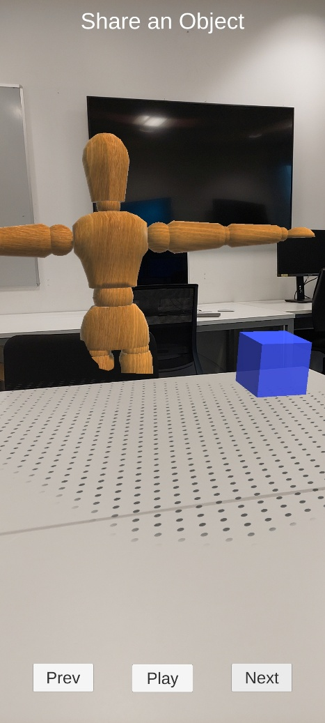

Figure 2 Examples of the user view of the data gathering application

Each participant was assigned one of the two scenarios (smartphone or HoloLens), alternating between the options to ensure a balanced distribution. Each participant was given a brief introduction and an explanation of what was expected of them by the researcher. Additionally, they were given a brief tutorial of the basic usage of each setup. Special emphasis was placed on showing how they could put their hands in front of the camera to simulate an interaction, but they were still reminded that they could do whatever they thought would be most natural or straightforward to achieve the action presented to them.

All participants would then proceed through each task performing any number of interactions that would come to mind and trying to verbalize their thought processes and logic. Participants could propose any number of interactions. If none of the proposed interactions were air gestures, the researcher would remind them of that possibility. Tasks were always given to the participants in the same order to simplify the process of explaining the task context and managing the flow of the session.

The specific emphasis on air gestures is due to their strong association with AR technology, which often uses image recognition techniques to track the users’ hands and use them for interactions in a more natural and intuitive way (citation needed). It was also theorized that participants would not be necessarily familiar neither with the technology or those common interaction metaphors, so it was decided that an explicit mention of air gestures after the first round of proposals made by the users would help in the generation of ideas and would also help gather data concerning the hypotheses build for each scenario.

To capture the raw data, all sessions were recorded with a video camera for future analysis. The recordings took place over several weeks and in different spaces, sometimes with the participants seated and some other times with them on their feet, but always with the same equipment, the same test software and following the same procedure.

Another important decision was to gather data of each participant individually. Although the interactions were associated with group activities, the was no need nor the process gained anything by simulating the full teamwork experience. On the other hand, the process would require a more complex process, the coordination in time and space of several participants and for the mock-up software to also grew in complexity to accommodate several uses. It was deemed as an unnecessary development. The procedure clearly explained to the participants that the activity meant to simulate a teamwork scenario with other humans, and some measures were taken to add to the animations presented by the software simple representations of other users to give the participants a visual idea of the scenario presented to them.

Each of the recordings underwent analysis to create a transcript of all the participants’ comments and ideas, as well as to identify common thoughts, problems, and solutions. Video footage of each session was processed to compile a library of all the gestures performed for each task. Each individual performance of a gesture was given a score from 1 to 3, with the highest score given to the first gesture proposed by a participant. If a participant proposed two or more gestures or proposed a gesture after being prompted by the researcher, those gestures were given a lower score. This means that gestures with a higher score were performed the most and could be interpreted as the most natural or intuitive reaction for most of the participants. All gestures after the third proposal received a score of 1.

A total of 478 gestures were proposed for all tasks. Although each task clearly converged to a specific set of gestures, agreement in general was low. For each task, agreement was calculated using equation 1 (Wobbrock, Aung, Rothrock, & Myers, 2005).

$$A\text{= }\sum_{N}{{(\frac{P_{s}}{P_{t}})}^{2}}$$

In this equation, Pt is the total number of gestures performed for a task, and Ps is the number of times a distinct gesture was performed by different participants. This gives a value of agreement for each task up to 1, which would mean that every participant

proposed the same gesture for the task, while a value closer to 0 means that every participant proposed a different gesture. Figure 3 shows the level of agreement reached for each task and in each scenario in descending order.

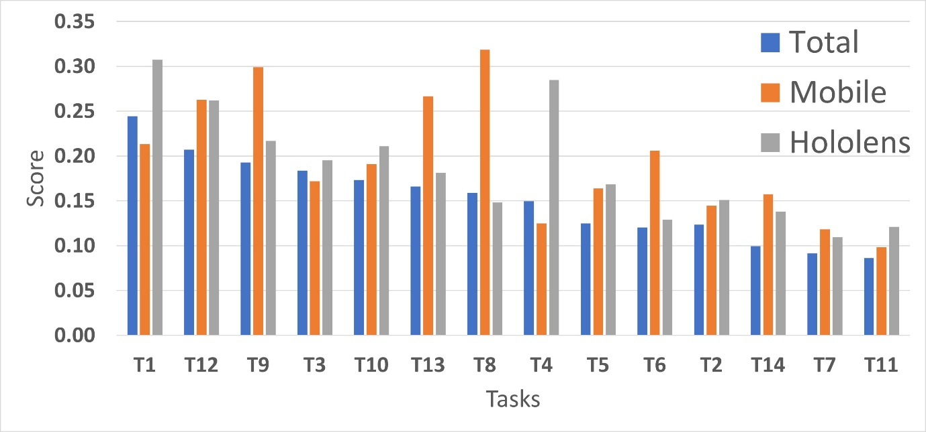

Figure 3 Total agreement scores for each task, separated by scenario

Overall, tasks 1, 12 and 9 had the highest agreement, corresponding to pointing at an object, pausing your participation, and voting for an option on a menu. Although these tasks are the most prominent examples, all of them behave in the same manner, with most of the participants agreeing on one or two gestures, but the rest proposing a very granular or unique set, generally bringing down the agreement score significantly for all tasks. It is also important to note that the agreement score for both scenarios aggregated is a bit lower than when separated by scenario. Tasks 8, 9 and 13 had a better score in the mobile scenario, mainly because they were strongly associated with touch actions on the screen and most participants converged to such interactions. On the other hand, the HoloLens scenario had better scores for tasks 1 and 4 (point and hold and object), probably because they suggested obvious or natural hand movements to which most of the participants converged.

### 5.1.1.2 Proposed Interaction Gestures

Based on all the data provided by the participants, a library of 39 gestures was selected as the final user-driven selection. These gestures cover 56% of the total proposals and the set of each task represents between 50% and 70% of them. The following section will show the final agreement score for all the unique gestures identified in each task, as well a visual example of the gesture selected for the final set collection, the one that exemplifies the best the suggestion to which the users converged at. It is possible to check a library of the video captures for all the gestures identified in each task in Annex 1.

Tasks 1, 2 and 3 are related to pointing elements of your environment to the team

members. These tasks were the ones with the highest agreement scores in both scenarios.

Participants defaulted to pointing with one or two fingers towards the camera

in the general direction of the digital object or trying to cover it by superposing the

gesture over the object. Figure 4 shows the agreement score for the 11 unique gestures identified for the task.

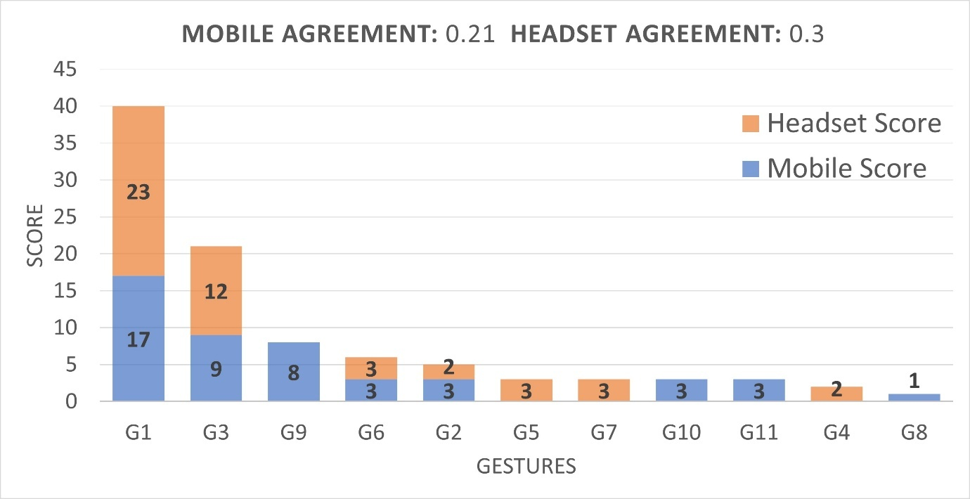

Figure 4 Agreement scores for unique gestures in Task 1

The selected gestures involved pointing directly to the object with one or two fingers, with a stronger tendency for this gesture in the headset scenario, while mobile users defaulted more to tapping motions in the screen. The most important reasoning given by the users behind the tapping behaviour was that the motion was “natural” or “common”, especially for a touch screen. In scenario 1 some users also mention the naturality of the tapping motion in relationship to how they would select an option in a touching screen, highlighting the influence of previous knowledge when translating the actions to a scenario that is similar or somewhat familiar. The tapping motion also included stronger deviations of the gesture, like using the whole hand or exaggerating the pointing motion of the object to make clear the

intended selection and eliminate ambiguity in the selection, a concern mentioned by some users.

Another relevant gesture proposed was a variation on grabbing or holding the object to signify to others that “this object here that I am shaking is the one I am talking about”, to use the words of one user. The mechanics of holding the object varied a lot between users, sometimes using one hand or both, and with or without movement involved after the grabbing motion.

It is also important to mention that the task was described to the users as “pointing” to an object, which could have predisposed the users to a particular set of gestures. The task was described as such to convey the idea that the action was done for the benefit of another user, and that the main objective was to highlight the object to another person, not only to select the object. Nonetheless, a more neutral term could have been used, like “show”, “mention” or “indicate”. Figure 5a shows an example of the selected gestures for task 1, Figure 25a depicts T1G1: Pointing at the object with the index finger, while Figure 5b shows T1G3: Taping the object with the index finger.

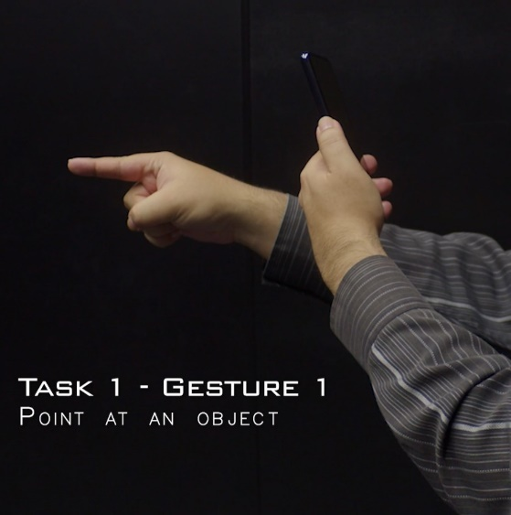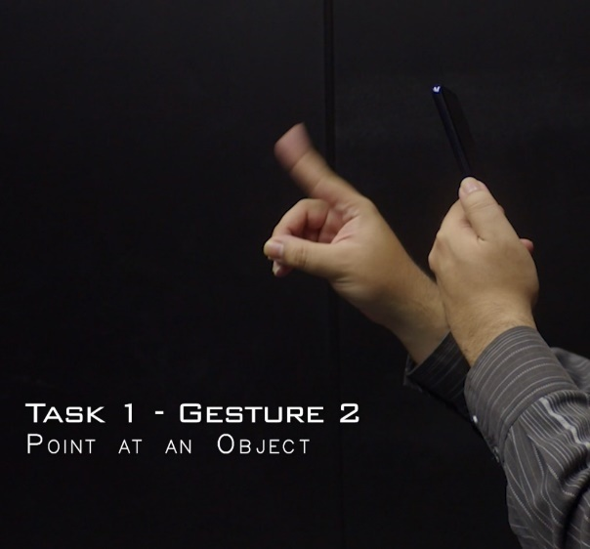

Figure 5 Point at an object – Pointing Index (left) and Tapping Motion (right)

Task 2 yielded very similar results. Participants tended to use more descriptors or directions related to real-world elements. Phrases such as “the one next to the chair” or “the one next to your hand” were common, but these comments were always accompanied by the same pointing gesture. Figure 6 shows the agreement score for the 15 unique gestures identified for Task 2.

Figure 6 Agreement scores for unique gestures in Task 2

A significant number of users defaulted to use the whole hand for the pointing gesture, but it was not possible to identify a reason for such a difference in comparison to Task 1. Figure 7 shows and example of this gesture. Another somewhat common proposal was to draw some figure to enclose the point in space being pointed at, like a circle, an X or some movement of the fingers.

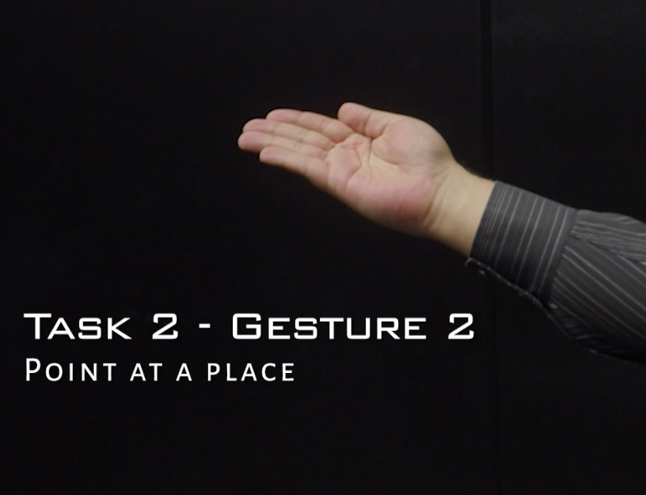

Figure 7 Point at a place – Extended hand gesture

A similar situation presented in Task 3 when pointing to a person. In this scenario, the extended hand gesture was explicitly explained by the participants, who expressed reservations about pointing at someone else with a finger, considering it disrespectful. They preferred to point using the entire hand or by tapping on the screen. Otherwise, the same tendencies shown in the previous two tasks were also present in here. Figure 8 shows the agreement score for all the 13 unique gestures identified for Task 3.

Figure 8 Agreement scores for unique gestures in Task 3

To wrap up the observation of the pointing category, it was observed that users defaulted to point to objects using an air gesture with either the index or the whole hand. Users also commonly referred to their previous experience with touch screens, founding natural the selection of objects using a tap in the air or the screen. There was not much difference between pointing digital or physical objects, but several participants had second thoughts and concerns when pointing people, considering the index gesture as rude or inappropriate.

Tasks 4, related to holding and manipulating an object, was designed to examine how the two scenarios would influence the participants’ interaction proposal, especially considering that Scenario 2 provided the freedom to use both hands. There were indeed instances of gestures only appearing in Scenario 1 and others only in scenario 2. The use of mobile phones led some participants to default to a familiar drag gesture over the screen to hold and move the digital object, which was only possible in that scenario.

On the other hand, the headset scenario strongly promoted the participants to use the perceived physicality of the digital object to try and grasp its contour using the index and thumb or even with the whole hand, as shown in Figure 9. The next most popular gestures used a simpler approach of grasping the object by completely closing the hand over it or pinching it with the index and the thumb. Nonetheless, participants strongly defaulted to the most complex yet more realistic approach when using a headset.

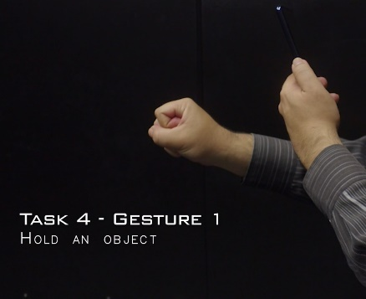 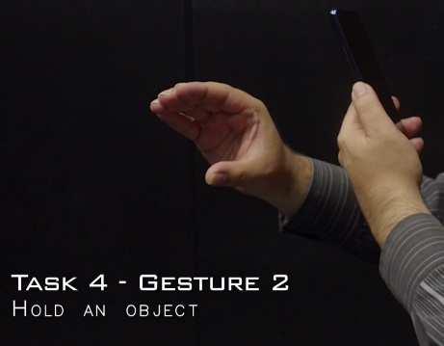 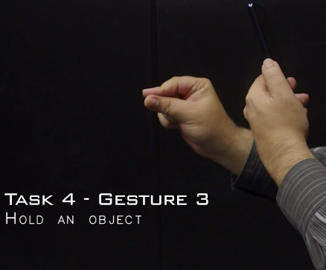

Figure 9 Hold an Object - Closed Fist (left), Contour (middle) and Pinch (right) gestures

Task 5 is the collaborative take of the object manipulation category and was meant mostly on gathering ideas from the users on how to organize the group while manipulating objects. The participants were specifically prompted to explain how they would share a held object or the act of sharing anything in general. In this case, both scenarios converged to the gesture of extending an open hand in the direction of the intended target, either to automatically trigger the sharing action (a very straightforward, abstract action) or as the first step of a process, expecting the other team member to extend their hand and take the object (a more realistic, physical action). Mobile users also converged to the motion of “throwing by swiping” the object

in the direction of the intended target. Examples of all these gestures can be seen in Figure 10.

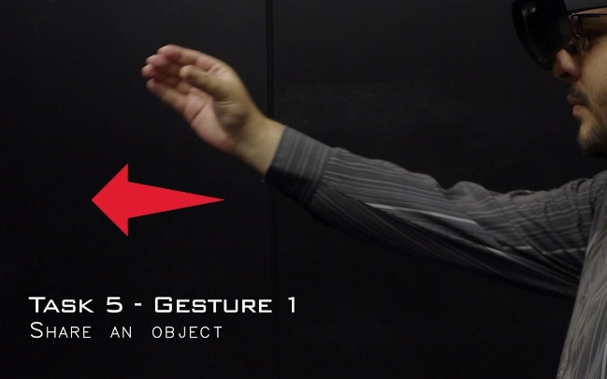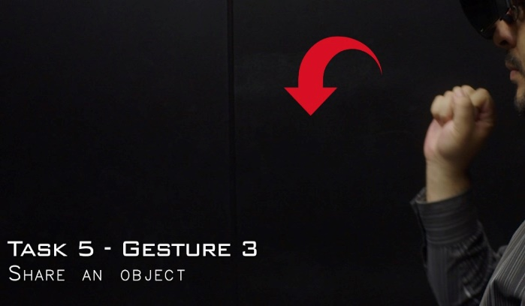

Figure 10 Share an Object - Pass over (left) and Toss (right) gestures

For these gestures related to sharing and collaborative manipulating objects the participants proposed increasingly more complex gestures requiring full movements or patterns to convey the intended meaning (which are harder to show in static figures). Movement ranged from simple patters like swipes or tosses that only required a direction or a reference to the target team member, while others proposed complex series of movements normally involving the other user in the action, with specific protocols required to initiate the sharing of an object and its receipt from the second user. Figure 11 shows the agreement scores for all the gestures identified in Tasks 4 and 5.

Figure 11 Agreement scores for unique gestures in Task 4 (top) and Task 5 (bottom)

Tasks 6 and 8 corresponded to taking an object in and out of the private workspace of the participants. The shared and public space figure was an interesting concept that appeared in literature to emphasise the need to differentiate between public and private spaces in shared experiences. The shared versus private workspace create a boundary for each user to be able to keep work and experimentation as private work and be able to control what is shared with the team and what is not. In terms of interaction design it also offered the opportunity to understand how users would understand this concept, if at all, and if it was possible to converge into a set of gestures to represent possible actions needed for this scenario. It was decided to focus on the process of moving from and into the private space and how can this be signalled in the shared experience. In this case, both data gathering scenarios clearly converged to different gestures.

Both were similar in nature and consisted of moving the object with one hand to and from the area shown to participants as their private workspace. The difference appeared when participants in the mobile scenario saw a zone in the border of the phone’s screen and dragged the object there using a hold-and-drag gesture. Few people took the object with their hand, and if they did, they did not consistently use the same gesture proposed in Task 4.

On the other hand, headset users saw a zone in their physical space and moved the object there, sometimes holding it using the exact same gesture proposed in Task 4, but not consistently. Other times they would use a completely different gesture to hold and drop the object or would use a different one related more to push the object into the zone or drag it close to their own person. Figure 12 shows examples of the converged gestures for both tasks.

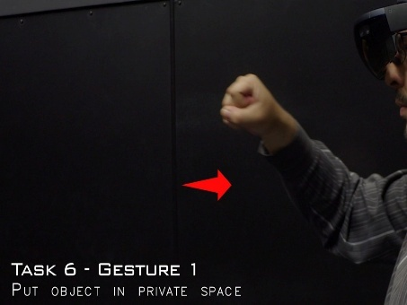 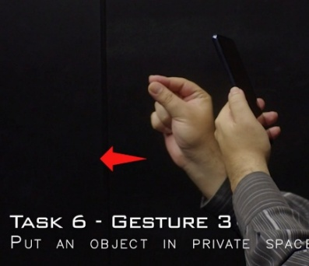 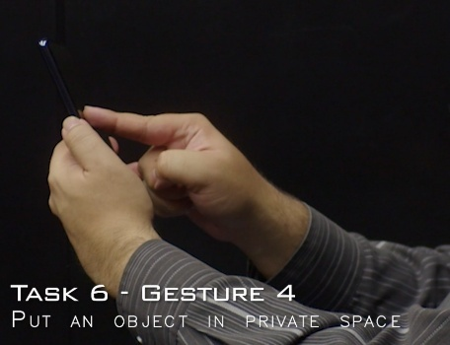

Figure 12 Put an Object in Private Space - Fist hold Inwards(left), Pinch Hold Inwards (middle) and Screen Swipe (right) gestures

This distinction between scenarios is very probable due to the way the private workspace was shown in each scenario: a 2D space on the screen for Scenario 1 and a 3D area near the user for Scenario 2. This could have prompted the participants to use the screen rather than an air gesture. Nonetheless, it is also probable that the screen interaction would have been one of the most prominent results even if both scenarios would have shown the same representation of the tasks, considering how for tasks 4 and 5 mobile users also defaulted to interactions using the screen despite the mostly 3D representation shown to them in the application.

The idea behind Task 7 was not necessarily collaborative in nature, mostly exploring a common action in any other software that could be expected by users in the functionality of WorkshopAR. Its implications in the coordination of action when manipulating objects could also be discussed. In the end, Task 7 represented one of the less agreed upon sets, and showed a variety of approaches to signal the process of undoing the previous action, but the most agreed upon comment among both scenarios was that such an action could better be implemented via a button or option in a menu, and not linked to a gesture, either in the air or the touch screen. This is important because this idea became more prevalent in the following tasks. Figure 13 shows some of the most common gestures proposed for the task, while figure 14 shows the distribution of the agreement score for all 22 gestures identified.

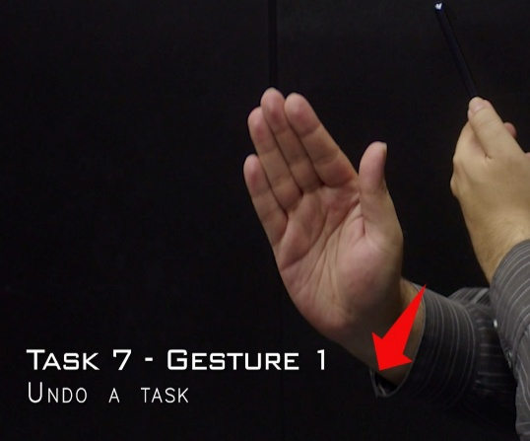

Figure 13 Undo a Task - Push Sideways (left) and Wave (right) gestures

Figure 14 Agreement scores for unique gestures in Task 7

Tasks 9 and 10 asked the participants to vote in a debate or answer a multiple-choice question. The tasks were designed to identify differences in interaction when the participants had to interact with a clear user interface in comparison to a more physical selection involving objects in the digital space. Curiously, and due to the decision of keep the order of all the tasks the same for every participant, observations regarding this issue already appeared in tasks 6 and 8 when presenting headset users with a more physical representation of the private workspace in comparison to the UI representation shown to the mobile users. With these tasks, results were consistent among both scenarios and behaved as initially observed.

Task 9 showed a static menu on screen to represent the voting process, and as expected, it converged to simple selections over the user interface, normally a tap in the screen or a pointing gesture in the headset. Major distinctions consisted in changes in the pointing action, like using two fingers instead of one. The biggest variants used exaggerated version of a tap, like a stamp with the whole hand or a punch. Figure 15 shows examples of the selected gestures for this task.

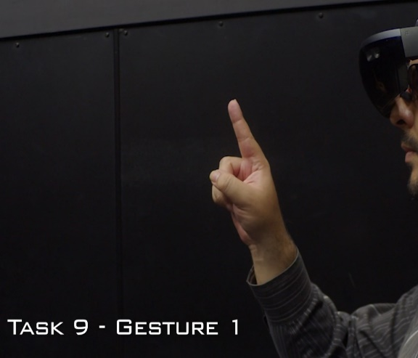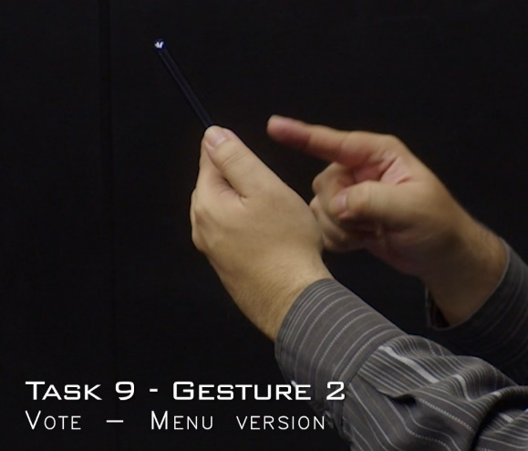

Figure 15 Vote in a Static Menu - Air tap (left) and Screen tap (right) gestures

Task 10 promoted more variety. Pointing was still the most common gesture in both scenarios, probably because the 3-dimensionality of the objects promoted air gestures, even in Scenario 1. Holding the selected object was the other most common proposition. Like Tasks 6 and 8, the holding gesture was not consistent with the ones used in Tasks 4 or 5. Yet, both scenarios converged to the same holding gesture, particular for this task. It consisted of holding the contour of the object from the top. Because in Tasks 4 and 5, the holding gestures were accompanied by the expectation of having to manipulate the object in some fashion, participants probably preferred a more precise grasp that allowed easy rotation and inspection. Task 10, on the other hand, only required to signal the selection of the object, and merited a simpler hold. Figure 16 shows examples of the selected gestures for Task 10.

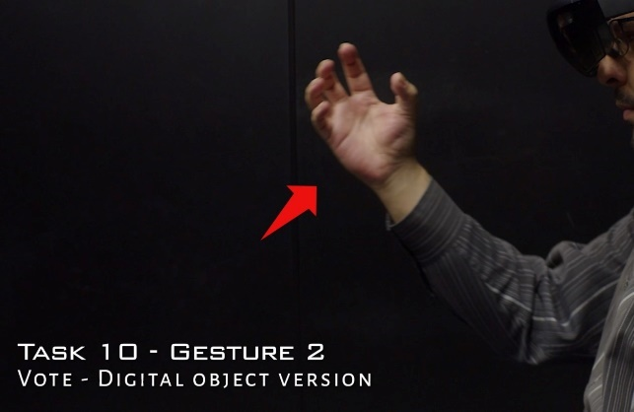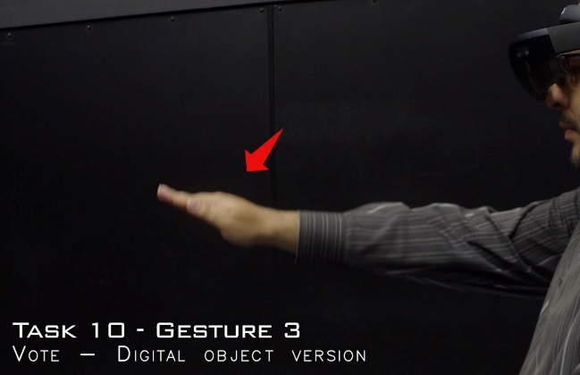

Figure 16 Vote with a Digital Object - Contour Hold (right) and Object Tap (left) gestures

We can also speculate that the way the objects were shown to the participants affected the decision-making process. The objects were anchored to the table or surface where the visualization was taking place, which probably promoted a natural reach-and-take motion. If the objects were floating in space or shown in a more abstract manner, reactions might have been different. Figure 17 shows the agreement score distribution for both version of the voting tasks and all the gestures identified.

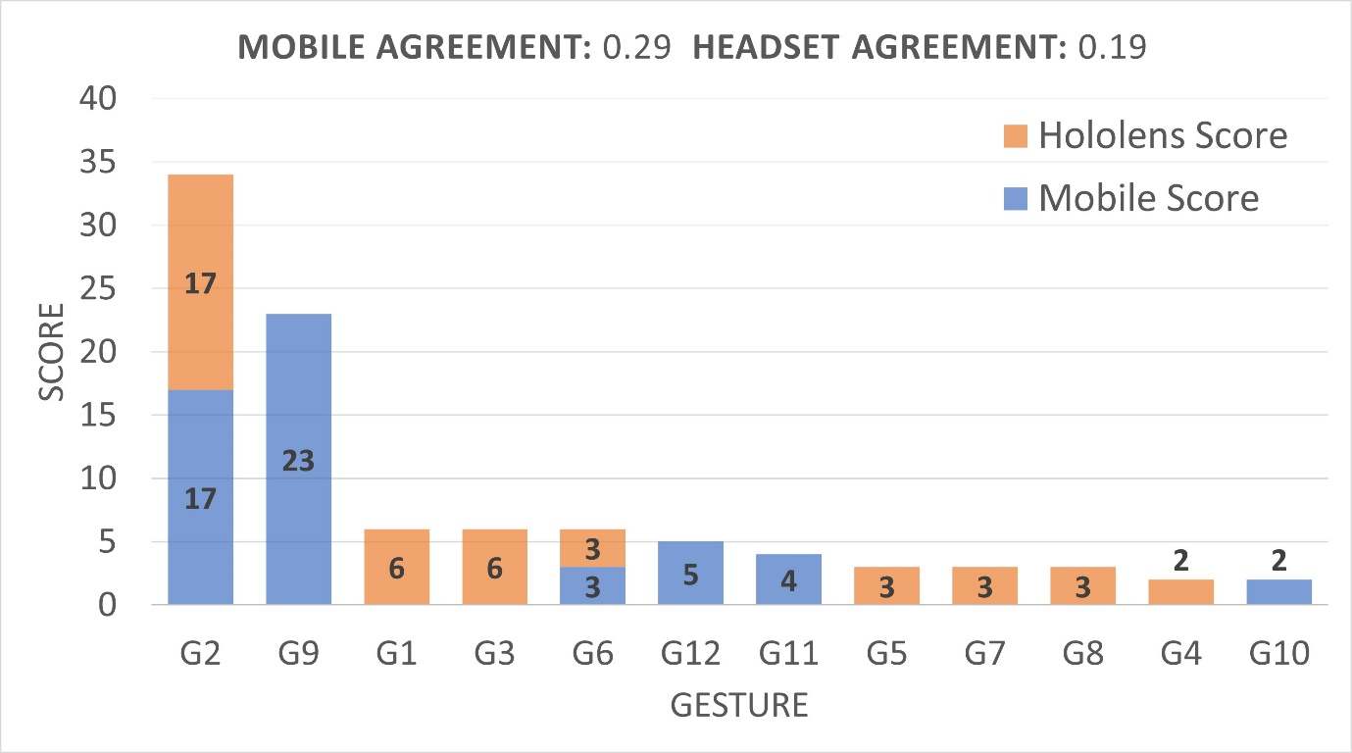

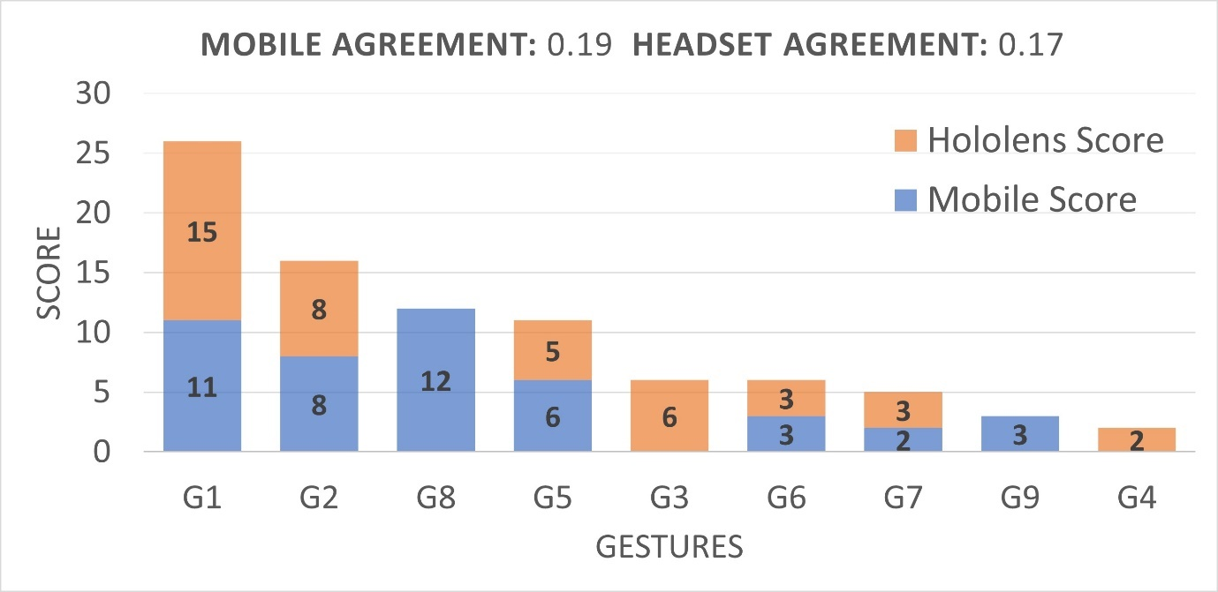

Figure 17 Agreement scores for unique gestures in Task 9 (top) and Task 10 (bottom)

Tasks 11 through 14 presented activities common in managing a group such as organize a conversation, ask for attention, or signal a pause in your activities. These tasks presented the higher variety of proposed gestures, mainly due to their abstract nature and because participants considered they represented more a process than a simple action that could be triggered by a gesture.

Tasks 11, 12 and 14 converged to simple air gestures that commonly represent their respective actions in real life. Asking for attention, either for teammates (Task 11) or for every group (Task 14), was represented by raising a hand, often with the variation of waving the hand. Signalling a pause in participation (Task 12) was represented by showing the palm of one hand in a stop motion. Figure 18 shows examples of these gestures.

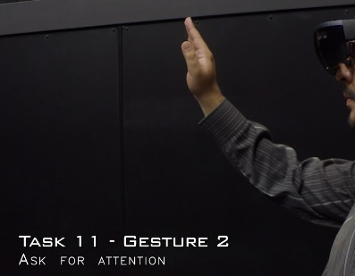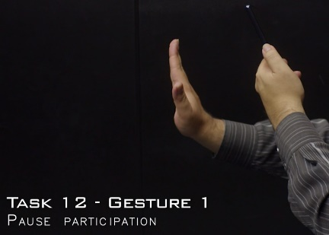 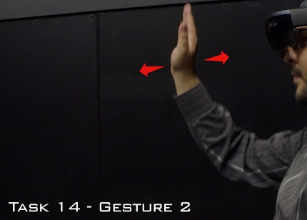

Figure 18 Raising hand gesture for Task 11 (left), Task 12 (middle) and Task 14 (right)

All these cases are good examples of proposals that would pose a conflict in an actual interaction design because they are practically identical, the main variation only being the height of the gesture or what side of the hand is shown to the camera. Among several other proposals for Task 4, Task 9 and Task 10, there is a conflict between natural, significant gestures, gestures detectable by the technology and complex gestures that make sense to a human but would add to much complexity to the process guided by a software tool.

Another interesting observation for these tasks was that a lot of participants also converged to a form of voice command to ask for attention or to communicate any status of the activity, arguing that it would be more natural to simply talk with your teammates if they are near, rather to rely on the software to control the whole action.

Task 13 represented an action meant to convey order to a group discussion, and a form of control of who was speaking in each time. Results behave similarly to the previous examples, with participants arguing that the tasks fitted more into a process than a single triggering gesture, effectively dividing the task in two distinct steps: a gesture for stopping someone from talking, then another for giving someone the turn to speak. Few participants tried to give a gesture that encompassed the whole process, and it was always a composite one, made of distinct gestures or movements for each part. The gestures for stopping people from speaking were similar to the gestures for Task 12 and pointing at people was the preferable method to signal the turn of speaking, like the gestures for Task 3. Figure 19 shows the agreement scores for all the gestures identified in Task 13, while Annex A contains video records of all gestures, especially for those that are hard to show in printed form.

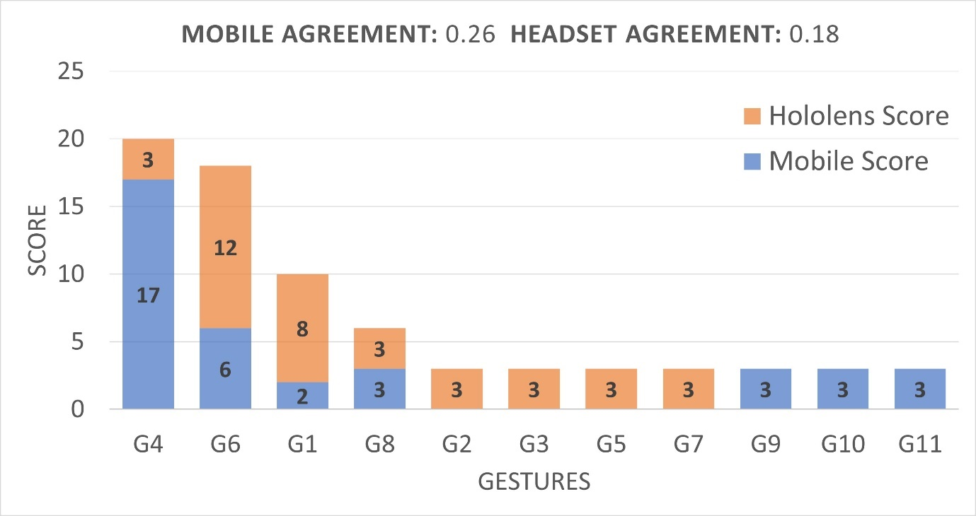

Figure 19 Agreement scores for unique gestures in Task 13

### 5.1.1.3 Analysis and Conclusions

Participants also provided an extensive catalogue of ideas and commentary that accompanied the proposed gestures. These ideas and general conversation provided were compiled and analysed using transcripts or the recordings. The main ideas discussed were organized in major categories that contextualized each participant’s proposal or that promoted some form of discussion around the methodology, the setting, or the technology.

The first major element identified was related to all the things that influenced in some way the decision-making of the participants, and that prompted or facilitated the same types of gestures or the same type of ideas and issues to arise. For instance, participants assigned to Scenario 1, which used a smartphone, defaulted immediately to use the screen as their main proposed gesture of interaction. By far, the major intervention that the researcher had to do during the data gathering was to remind participants in Scenario 1 about air gestures, and when participants referred to some gesture to be “natural” or “logical” to solve a task, most of the time they were performing a touch gesture in the screen.

Of all the participants interviewed, 60% reported not being familiar with AR technologies, which can translate to most of them feeling more comfortable or seeing as more logical to use a known touch gesture in the screen or UI elements to perform any task. Even more, people that reported to be knowledgeable of AR also reported to understand how air gestures work and how they are recognized by the technology, as well as being aware of the limitations it possesses, which derived into preferring touch interactions or UI elements because they recognized air gestures as impractical or too difficult to be recognized.

In comparison, headset users in Scenario 2 had no other option than to propose air gestures due to the nature of the technology. We can hypothesise that given a more recognizable mean of interaction, like a controller with buttons, participants would have also defaulted to use it. An interesting aspect about the air gestures proposed by headset users is the realism of the actions. Hold gestures, for example, would consider the size and contour of an object and its position in space.

Finally, the way tasks were presented to the users through the application also affected the proposals. Some of the participants based their gesture mainly on the animation shown to them, like the movement of objects or some visual effects meant to signal or represent things, like a selection or someone performing an action. Similarly, any UI element predisposed the participants to think in UI interactions. Closely related to this, some participants assigned to Scenario 2 where completely fixated to the default select gesture of the HoloLens headset (a pinch with the index and thumb), which had to be taught to facilitate the interaction with the device.

Independent of the scenario, some other common situations were present when participants tried to explain or justify a gesture during the think-out-loud activity. The most common discussions emerged when the participants themselves found issues or flaws in the hypothetical scenarios created by them to explain or understand the gesture proposed. These were very valuable pieces of information because they showed how the user expected something to work and how they would use it in a real scenario. Some outstanding

examples were:

* People feel awkward mediating conversation by technology. The extra steps in the communication process were seen as a problem or in need of too much justification to feel natural.
* People expect the technology to detect a lot of social cues used in normal communications, such as sounds, gaze, and facial expressions. These cues also vary a lot between cultures.
* People who are not familiar with AR interactions feel more comfortable with gestures that mimic actions in real life or convey an understandable meaning, despite more abstract or simple gestures being easier to use. In contrast, the more familiarized the participants were with the technology, they expect simpler and more concrete gestures to be available (like touches, taps or drags).

This user-driven design exercise gathered 24 participants to identify natural air gestures

for interaction with an augmented reality application in a collaborative setting. The participants proposed a total of 478 gestures to cover 14 different tasks related to interaction with teammates and sharing a common goal. Of those gestures, 195 were unique propositions organized based on level of agreement to make the final selection of 39 gestures, which represent what the participants considered the most natural means of interaction with AR technologies either using a smartphone or a headset device. The resulting set of interactions is a useful tool to start thinking in the design of a collaborative AR application and the issues that must be solved in a concrete solution such as WorkshopAR.

This design approach proved to be a valuable technique, especially suited for early prototypes of an idea or to understand the impact of new technologies. The results obtained went beyond the proposed gestures, and a valuable collection of information was gathered related to how the users perceive the technology, how they see themselves using it and the issues, problems and opportunities that could arise in different contexts proposed by the users themselves, and that could have escaped the scope of a development team.

This research was proposed under the premise that collaboration is an important aspect of the value proposal that AR can convey. With the advent of new consumer products available on the market, it is necessary to understand how to use this technology in a social context, and how the process of communication itself can change when similar tools gain more popularity and mass adoption. Communication itself is a big aspect of any collaborative task, and we still need to learn more about how interactive technologies mediate those communication processes, how to mitigate the issues that will arise and capitalize on the benefits. Particularly, given the context in AR that this project holds, it can be interesting to research and analyse what it means to augment communication, collaboration and social interactions.

## 5.1.2 Implications for the implementation of WorkshopAR

The previously exposed research effort had a broader objective of understanding and identifying natural approaches that users proposed to interact with AR technologies and how they related to the means of interaction currently provided by available products. Through the research it was possible to identify the complex interactions that users proposed when offered a hands-free form of control and how they related to the slowly building common language being developed around these types of controls. The metaphors and approached currently being developed in the industry are not yet widespread enough in the market or among the final users, which prompt users to have more complex or elaborated expectation of what the technology is capable to do.

On the other hand, when users are presented with a mobile, touch-based device (a smartphone), the situation reverses, and the users start to rely in their knowledge and previous experiences with touchscreens, expecting or defaulting to gestures and interactions that are the norm in the mobile design environment. The conjunction of these two scenarios creates a situation in which users could be completely unfamiliar with the technology and would need a substantial learning period to properly use an app, or could be very familiar with the device, which facilitates learning but also has to take into account expectations and behaviours that could either inform or clash with the current implementation.

Analysing this information in the context of WorkshopAR, it is possible to draw some important conclusions that informed the future design and development process:

1. From the selected set of gestures, it was possible to observe that both the touch screen and headset scenarios converged to gestures that were similar or compatible between each other. There were few instances of radically different proposals for each scenario.

The selected gestures where at the top or near the top of the agreement ranking and consisted mostly of simple static gestures (a tap or a point selection) or common movements (swipes, waves of pinches). The commonality among these gestures is that the work the same or at least very similar in both testing scenarios and can also be represented in a full air-gesture representation with little or no change. These first responses or initial variations to the first responses reflected a tendency for users to default to known and tried approaches to interaction.

This behaviour is supported by the design implementation followed by modern (as the writing of this document) AR-able products such as the Meta Quest 3 and the Apple Vision, which opted for simple and recognizable gestures like taps and pinches, even when the hardware is capable of robust hand recognition. Figure 20 shows some examples.

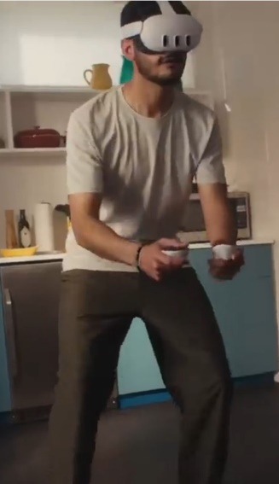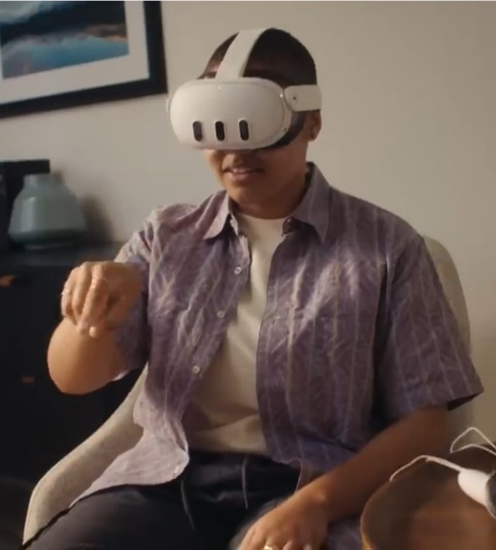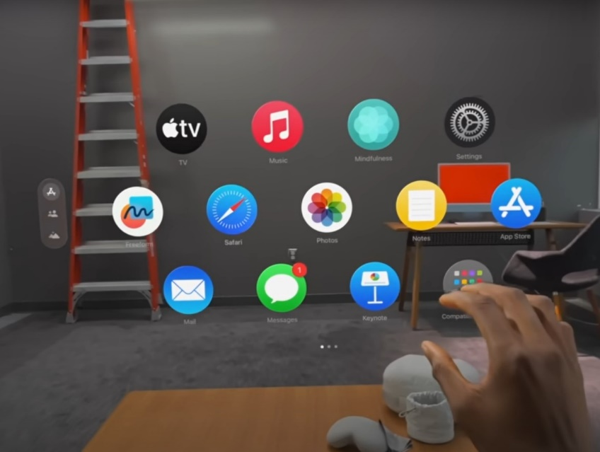

Figure 20 Interaction Examples with the Meta Quest (top) and the Apple Vision (bottom)[1]

This also echoes the data recorded from the ideas and justifications in the think-aloud sessions with the participants. Users indicated that the felt that the actions that could be performed in a smartphone for similar or parallel actions were more natural or correct and would even indicate that they would expect or wish for a functionality in the same venue for the application to be proper or correct.

For the development of WorkshopAR this indicates that the interaction design can focus on a single set of gestures for both mobile and headset deployment, opting for a “touch screen approach” that can be equally implemented on a screen or in a floating style UI. This would present familiar interactions for all users and would simplify the multi-platform approach.

2. The data shows that air gestures work better as abstractions, even when strong hand-recognition capabilities are present. Several users reported how unnecessary it felt to perform a complex gesture in a 3D space when a simple touch on a screen or in a UI option would suffice. This was especially present in the more process-driven actions like voting in a debate or pausing the current activity.

Given this observed behaviour it was considered as an opportunity to simplify the general interaction design of WorkshopAR to consider only standard gestures. Although air-gestures represent and interesting development and research topic, for the overall goals of WorkshopAR would divert time and resources that would not properly translate into data for the proposed research questions related to collaboration and TEL. A simple set of gestures supported by a clear UI promoted a simpler production and a more straightforward learning curve for the users.

3. It is important to focus more on user-driven process rather than software-driven ones. Besides providing a set of representative tasks for the data gathered, the set of activities proposed for the research was to prototype different ideas for the future functionalities of WorkshopAR. Tasks like the voting process and asking attention from other team members were ideas extracted from literature and that could offer value to the students using WorkshopAR.

Especial attention was given to the qualitative data extracted from the participants in task which such characteristics, and although every task converged to a distinct set of gestures, general comments and ideas mirrored confusion and frustration when trying to understand or justify the proposals. The main struggle related to ling what was viewed as a complex process to a single trigger action. Concerns on how to implement such gestures in a real application were also spoken. The data also showed that some participant found impractical or simply wrong to communicate to other people through the application when they were shared the same space and were at talking distance.

Paired with information obtained during the testing stage of the first implementation process, this prompted a strong change on the approach for the design of several of the functionalities of WorkshopAR. It was decided that a better approach was to hint or discuss ideal structures for the collaborative work of the users, but without enforcing it. This prompted flexibility in the usage of the tool and would lower the disruption that the data gathering process could create in the workflow of the students during the course sessions.

In summary, the research process on collaborative gestures informed several aspects of the interaction design of WorkshopAR in terms of understanding the expectations that users have with the technology, the best road to approach the most physical aspects of the interaction design and how to promote the ideas at the core of learning goals of the application. In general, this approach can be summarized as:

* A focus on simple gestures that prioritize touchscreen recognizable actions.
* Rely on process guided by the users and not the app.
* Promote structures rather than enforcing it

The following section will then show the final implementation process of WorkshopAR, the objectives achieved through the two development iterations executed, issues and problems encountered, and an analysis of the results obtained and the road ahead for future research and development.

# 5.2 Implementation Process

## 5.2.1 First Development Iteration

The main objective of the first iteration was to create a deployable test for the shared AR experience. Rather than approaching any of the use cases, the objective was to test different technologies and run trials on how to create the multi-user interaction. In more concrete terms, four objectives were established for a successful first iteration:

1. Create the “room” concept based on scanning the physical space and providing specific configuration parameters.
2. Create the “participant profile” by identifying the most important data needed for configuration and information display in the room.
3. Open the room for a session and allow participants to connect, acknowledging the interchange of information over the network and the visualization needed on AR.
4. Test the creation and interaction with digital objects during the work session.

At the beginning, the process focused more on testing different technologies and understanding the deployment of an AR solution over a network. Once the most relevant aspects of the infrastructure were understood, development move to the prototype of main usage loop, which can be specified as:

* Joining a configured room and visualizing other participants in the session
* Creating a workspace for the session.
* Adding and interacting with digital objects.
* Pointing at digital objects, other participants and other physical elements in the room.

Each of these objectives were considered as major milestones to achieve during the iteration and were used as the main markers for progress along the six months of development that the iteration approximately took. The development of each milestone was followed by a set of unstructured tests to gather quick feedback and incorporating changes and adjustments that could feasible be developed in parallel to the advancement of the other milestones. Important points of changes that were not possible to quickly incorporate or that required a major pivot in development were logged for the next iteration or even tagged as analysis points for future work.

The following sections will explore the results obtained for each milestone and the data gathered in each testing phase. It is important to remark that the process itself was not as structured or as sequential as explained. Although there were a clear plan and a tangible set of goals guiding the process, each milestone was work upon and tested in parallel and at different point of development, keeping a constant communication loop with testers and stakeholders but without following any formal sequence of steps or staged process. The following analyses are shown in isolation to facilitated communication and exposition but work itself was more fluid and less sequential.

### 5.2.1.1 The room and the workspace

The concept of the room was defined as the physical space used to hold the work session, represented in the app as the network session that coordinates all the participants and the digital objects. The room itself is constructed and coordinated by several elements of the architecture (see section 4.3.3), and is not centralized at all, neither in terms of processes nor software components. Nonetheless, this architecture is transparent to the user, who only needs to understand the room as a digital space that can be entered to initiate the session, and that holds all the digital object need to work.

Two major principles guided the implementation of the room. In first instance, the room hints at structure without enforcing it, a major design focus in the development of WorkshopAR. The room indicates that a work session is happening, and to enter the room means to start focusing on the tasks and goals planed for the session. If a user is not working, then that person shouldn’t be in the room, but without leaving the physical space shared with the other teammates.

Following a similar line of though, hopping between rooms acquires the meaning of getting in and out of different workflows, each one compartmentalizing goals, resources and results, something hard or even impossible to achieve in a physical sense.

The second principle is related to anchoring concepts and ideas to physical elements. It is a principle also linked to flexibility, to make the users think about allocating and space suitable to work and to gather all the needed resources, but allowing the use of any type of space, not only a literal, physical room. Any space could be augmented to fit the needs of the work session. The idea of collaborative augmentation is also at play here, so that the users can stablish a link between the selected space and all the digital information selected, adding a layer of information to the space that can signify whatever meaning the users want it to have (a wall for ideas, another for issues and another for opportunities i.e.). Figure 22 show the basic configuration of the room that is create ant the beginning of the work session.

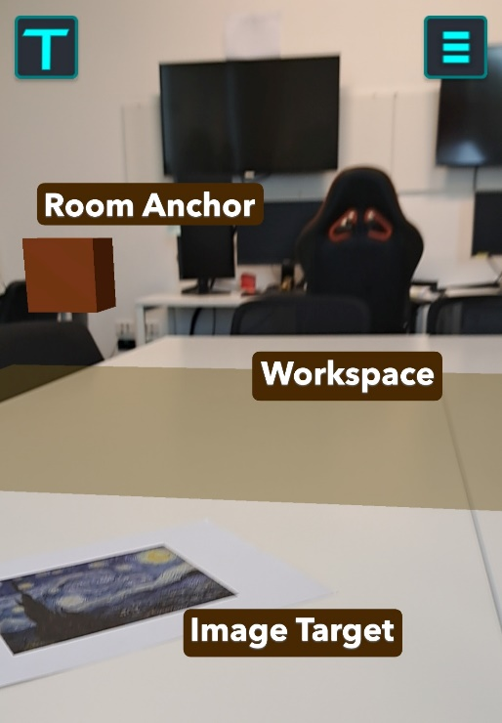

Figure 21 Basic Configuration of the Room

For the technical implementation it was also important to introduce the concept of the host. The implementation followed for Lightship required for a user to act as a host for the network session, since it was decided that the network architecture would follow a serverless approach to facilitate development.

There was the possibility to completely remove the terminology of a host from the side of the users since the concept was really only important for the technical implementation, but a couple of ideas made it worth it to use the term as part of the user experience:

* Users are familiar with the term in the context of video calls or video conferences (like zoom or Microsoft teams). The idea of “hosting” a meeting of that there is a person responsible for “making the call” is understandable to the users. Comparing the work session with a video conference could be beneficial for understanding the structure of the activity, although it also proved to bring some baggage with it as will be shown on chapter 6.
* It prompts the idea of designating roles to each participant and to allocate tasks and responsibilities.
* It made the process of creating and launching the room clear and easy to explain because a lot of known metaphor could be used (like the video call or being the host in a room or house).

As a matter of implementation, the host user only needs to select the room creation and provide a room name, which act as unique ID for that room in Lightship, as shown in Figure 22. On the other hand, a client user can search for all the available rooms created so far for WorkshopAR. In a more realistic scenario, in which several groups would be working at the same time, it would be necessary to implement more tools for users to filter and search with precision a room given its ID, as well as means to compartmentalize the creation of room inside bigger logical units like classroom or workshop, to create an easier and smother experience for several students at the same time using the application.

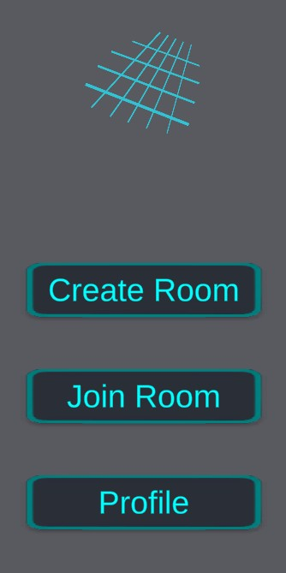

Figure 22 Interface for creating a Room or joining an existing one

At this point the other responsibility of the host is to establish the goals for the session, although this step is not necessary for the activity to continue. It would be the responsibility of the role to manage the goals of the session, either by tracking their progress or by updating the goals as the session progresses. These activities, and in general the role of the host about the management of goals, are for the group to discuss, organize and implement. All the other responsibilities of the host, those related to the coordination of information through the network, are done at the backend of the software, and thus are completely transparent to the user.

With this process the room is created, and the users are now connected through the network, but the visualization has not started. Both host and clients need to scan with the camera the configured Target Image to anchor the room’s shared origin. Simple QR patterns are normally preferred for this step because they are easy to detect, but any image can work and helps to configure the room with any resource at hand for with an image that holds meaning for the group or the current activity.

Scanning the image will establish the origin point of the room for the local user and coordinate the current state of the room (other participants, play models and annotations). The origin point is also represented by a digital object that can be interacted with to get the status of the room. Figure 23 shows the emergent menu upon interaction with the room anchor. This is the view of the host, who can add and remove goals. It is also possible to give the option for the client to have the same ability to manage the goals of the session, once again giving the option to decide how much or little structure they want to implement in the group.

Figure 23 Room Information Menu

The final responsibility of the host is the configuration of the workspace. If the room anchor serves the purpose of indicating that the session in progress, then the workspace serves to delimit the interaction area of the room. The workspace is a simple plane that holds all the play models added to the room during the session. It helps the users to position of the objects in the space and focuses the attention of the group into a specific point, avoiding a typical problem in AR where is easy to “lose” objects or menus in the surrounding space when they are not directly on view (Brudy, 2013).

Other possible designs for the workspace were considered, specially from the technical implementation point of view:

* Using the detected planes in the room the way they were detected, relying on the output of the Plane Manager provided by Share AR.
* Using a default plane, or even a more complex representation like a table or a whiteboard. The model could originate from the target image similar to the Room Anchor.
* Letting the users position the workspace in the same way they would position an annotation, relaying on the AR Raycast Manager provided by AR foundation.

The final implementation used the plane manager but did not totally rely on the information detected from the physical space. In first instance, plane detection (as implemented by most AR frameworks at the moment of development) continuously improves the detail of the plane by iteratively merging the features detected in the space to get more complexity in the object. It was considered that the opportunity to have a quicker setup of the room con be beneficial in the context of the classroom.

Second, it was important to not rely completely on the physical layout of the room to encourage the group to set-up a meeting anywhere that was convenient or at hand. The only requirement that the environment needs to provide is for a plane to be able to be detected, which in the worst-case scenario can be the floor. Any detected plane can be then modified to the desire shape and be positioned in the space as a digital representation of the work area for the group, either matching a current table or just providing the space floating in the air. Other technical requirements must be taken into consideration when detecting a plane, but they are more circumstantial. For instance, good illumination and surfaces with a good contrast like colour, a pattern or an irregular surface are easier to detect than plane, monochromatic ones. In the end, a compromise was found between a quick setup of the workspace and giving the user the ability to adapt it to the needs of the session.

For the configuration process, the host can see the iterative recognition of any horizontal plane in the room and select one that suits the needs of the session. The host can also transform the selected plane by moving, rotating and scaling it until it fits into the desired shape and position, but that it is not a requirement for the process to continue. Figure 24 shows the host view for the plane detection stage and the fine-tuning options.

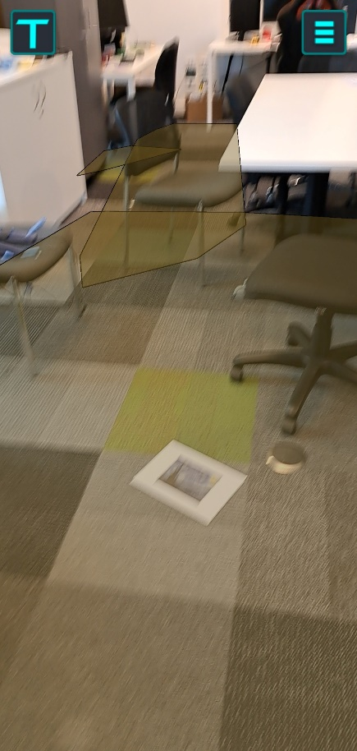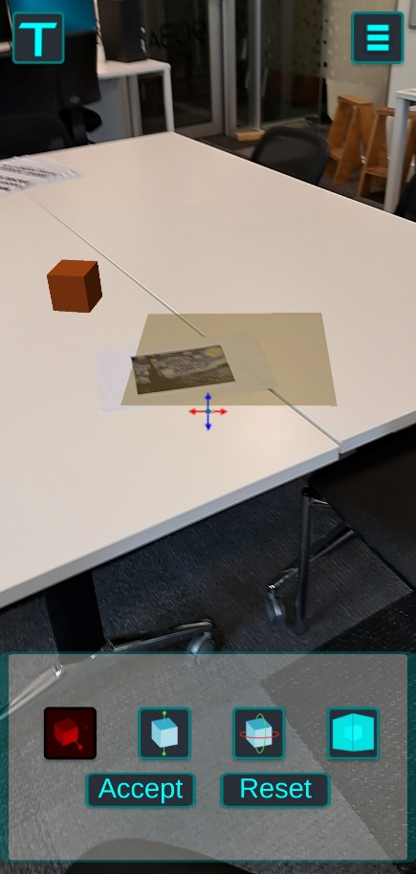

Figure 24 Iterative process for the plane detection (left) and workspace configuration (right)

With this the room configuration ends with the active responsibilities of the host, and the group can start the work session.

### 5.2.1.2 The User Anchor

With the main elements of the room represented it was also important to create that same element of visual representation in the digital space to each of the users in a session. For this there were two possible approaches:

* Recognizing the human face or figure and associate information of the participant to that detected feature.
* Add a digital avatar to the room that represents each participant.

There are important technological differences between these two options. For instance, face recognition is a common tool offered by most AR frameworks available but not at all categories of implementations in different devices (ARCore Supported Devices, n.d.), which could exclude potential hardware to be compatible with WorkshopAR. Incompatible hardware is not a surprising issue in this context, any technological product needs to consider the hardware ecosystem available in the market, but it was surprising to found how inconsistent was de compatibility of tools like AR core between different brands and different categories inside one brand. Elements like how new a device was, if it was a high-end or a low-end brand or the type of cameras available for the device had little relation to the presence of different AR features or not.

Another consideration regarding the face recognition option is data handling. There almost no issue for simple face recognition, that is, recognizing that a human face is present. Limitations and issues start to arise with more complex functionalities are needed. Recognizing and following a unique face, which would be the required functionality for this scenario, requires collecting and storing a significant amount of identifiable data for each test subject, which can quickly become impractical and an unnecessary ethical consideration.

This decision also became relevant thanks to the observed behaviour of test users during the AR gestures research. It was possible to notice that some users, those less familiar with AR technologies, had the expectation for the interface to behave in a more natural, complex way. The way the users are represented in the tool could also be part of those expectations, and for the user recognition to work as a seamless representation of everyone.

Just to pinpoint this possible behaviour and gather more grounded evidence of how the users would react to the different implementation possibilities, a small-scale test was designed that showed a sample of test users a render of the two possible representations of participants in the AR room, as can be seen in Figure 25. The subjects had to respond which option they considered the best implementation in terms of how they think the software should work and which option could offer a better interaction with the other users. The test offered a similar objective as the AR gestures research but in a different context and with other type of interactions in mind, but with the same core ideas of naturality and expectations for the technology.

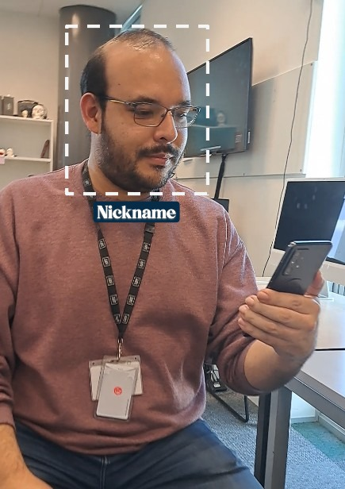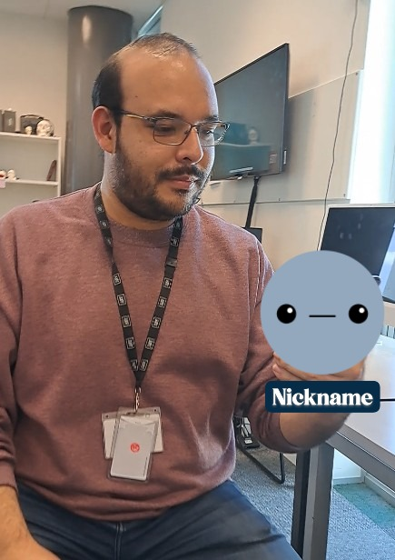

Figure 25 Face Recognition vs Digital Avatar

Despite the small sample size, results nicely aligned with previous observations. Some people found that the face ID option was more in line with how AR should work, how it seemed to work in adds and media representations of the technology. Several users remarked that they felt uncomfortable with interaction by directly tapping the person, especially in the face.

The avatar option received a surprising attention. Despite being described as a more convenient and realistic implementation, like with the menu in the AR gestures data sample, the avatar option was found as engaging, and as a “cute” option that promoted interaction. People wanted to interact with the avatar. These results highlighted the importance of the social aspect of any multi-user experience.

More technical aspects of the implementation shifted the final decision to a variation of the avatar option. The ability to uniquely identify each of the participants in a room consistently was one of the most complex challenges that had to be solved for a face recognition implementation. The development effort that that sole functionality needed made it out of the scope of the research by not providing critical information for the research questions. Additionally, it would have required sensible data of the users during the data gathering process, unnecessarily complicating the scope of the observations.

The final solution opted for a simplified avatar approach that followed the position and orientation of each participant’s device rather than the detected position of the user. This decision offered a couple of advantages:

* It was easier and faster to implement.
* Following the status of the device did not require to constantly have the room and the other participants on frame.
* It offered a more stable and consistent visualization.
* It drew attention to the device, which became an important part of the discussion about how to use smartphones properly in these types of collaborative activities.

The representation itself was simple and straightforward, conveying functionality first but communicating the idea of the possible customization that could be done with a commercial implementation of the functionality. Each participant was represented with a chosen colour for the avatar and showed to the other participant a nameplate with the user’s selected name for the session and a visual construct representing the gaze of the avatar, linked to the orientation of the camera in the device. The avatar also works as the interaction point for other participant to see more information the status of the user and to control how much of the visualization to be active at a given time, if it was found to distracting. Figure 26 shows an example of all these visual elements.

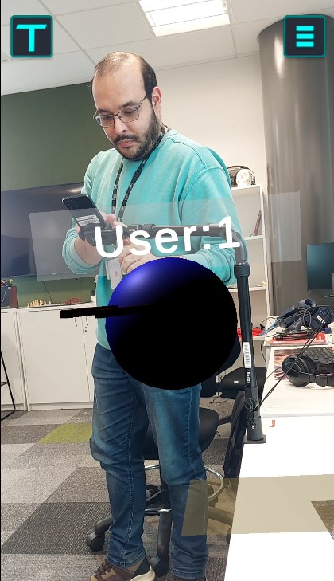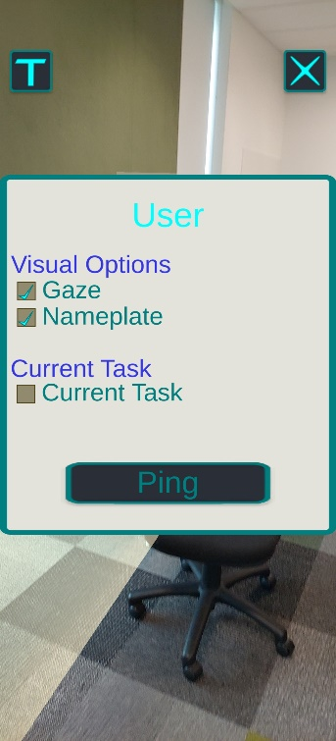

Figure 26 Visuals for the User Anchor object in the Room (left) and the information interface for a Participant (right).

### 5.2.1.3 Positioning play models

To test the implementation of the room setup two basic functionalities that involved sharing information through the network were implemented. The first one was the User Anchor, as exposed in the previous section, which follows the position and orientation of the camera in each participant’s device. The second implementation was a test of the general functionality for the play models, specifically, the procedure of adding and positioning a new model in the room.

The intended step-by-step process for this functionality would be as follows, from the point of view of a client user:

* Connect to a Room.
* Wait for the workspace to be configured.
* Select a model to add.
* Position the model in the workspace.
* Update the model for every participant.

For the first test round the full functionality intended for the interaction with play models was not necessary. The focus of the first implementation was to build and test the network backend and to receive early feedback and ideas around this functionality from the users.

The most important element in the Room for the implementation of the play models is the workspace. Each model is positioned in the room in relation to the workspace and will move and reposition if the workspace moves. Section 5.2.1.1 explained that his behaviour of the workspace helps the participants to focus on a specific area of the Room as the main interaction and visualization space, avoiding confusion, lost assets and excessive clutter. The design of the workspace also helps in the interaction with play models:

* It limits the space where a model can be positioned, making the process faster and less prone to errors.
* It allows the use of more precise tools for positioning in the augmented space, such as the AR Raycast, to improve the precision and visualization of the process.
* It can be easily expanded to create more complex interactions in future developments.

When adding a new model to the scene the user can user needs to use the camera to point at the position where the model should appear in the workspace. A previsualization of the model during the positioning helps the user to be more accurate. Figure 27 shows these elements of the positioning process.

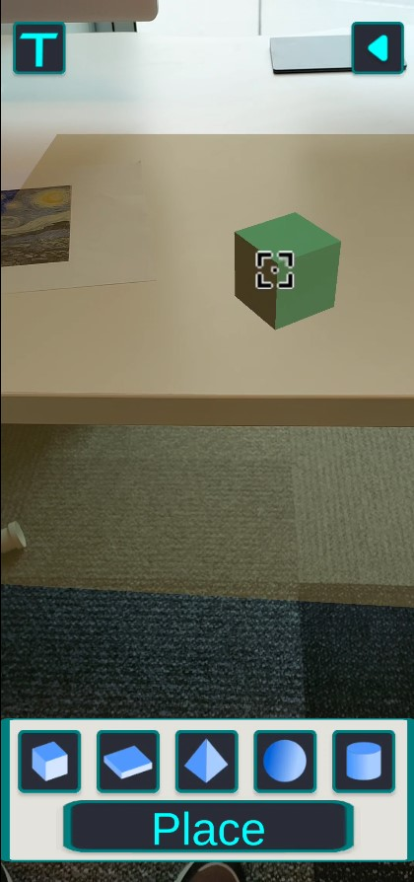

Figure 27 Play Model Positioning

Technology-wise, this was an opportunity to implement the design decisions described in chapter 4 about this use case. At this point, where no interaction with the model has been implemented, most of the development only concerns the backend that supports the process, which can be summarized as:

* Each client has ownership of the models they create.
* The status of each model is managed by the owner (the client) and coordinated through the network with the other users.
* The responsibility of the host regarding the play models is completely on the backend of the application and transparent to the user.

This summarizes the major implementations achieved during the first iteration of development, which resulted on the creation of the base procedure to create a shared room, the implementation of the major responsibilities of the host client and the configuration tools for the shared space. Good progress was also achieved in the three major visualization and interaction elements for the participant, the Room Anchor, the workspace and the user Anchor.

## 5.2.2 Analysis of the First Iteration

The time in between iterations was used to gather data from test users about the current state of the development and about the integration of the tool in the student’s work of the Industry Project course.

Two types of tests took place: first, unstructured tests focus on gathering feedback about the general interaction with the application, and second, small encounters with students with the purpose of introducing the app and the observation activities.

The unstructured tests were conducted with six different users across four days of testing. The loose protocol followed consisted on:

1. Ask the users to navigate the main menu of the application and create a new profile.
2. Ask the users to create and launch a Room.
3. Explain to the users the purpose and configuration process of the workspace.
4. Ask the users to scan the target image and configure a workspace.
5. Ask them to find the play models menu and position a model in the workspace.
6. Record observations from the researcher and feedback from the users.

The protocol focuses on gathering data about the user experience during the configuration stage of the Room. Records of the observations were done both on audio and written format, and mainly tried to highlight data about:

* Issues and friction with the current UI, taking into consideration that the users were not shown the final version of the UI in terms of aesthetics but they were interaction with the current proposal for functionality and usability.
* Misunderstandings with the procedures or points in which user got stuck trying to achieve and objective.
* Recurrent errors, mistakes or bugs.
* Recurrent positive comments.
* Open recommendations from the users of how something should work or behave.

In general, it was possible to consider the configuration process of the room as a success, the users considered the task clear and the controls easy or at least sufficient to accomplish the explained goals. The most prevalent feedback was related to the visual clarity of several of the UI elements present, especially with the controls for the fine tuning of the workspace. It was an expected issue considering that a proper UI design was not the focus of the iteration. It did offer several points to work upon when conducting the final UI implementation: Clear indication of what elements of the digital model are going to change when interacting with it (position, elevation, scale), the ability to quickly correct errors, revers unintended actions and verify changes before committing to them.

The most important highlight was observed consistently during the execution of the fifth task. When positioning the model in the workspace the user had to physically move the device to adjust the position of the model, since it was linked to the centre of the point of view of the camera. When executing this in a small workspace the was no problem, but it was observed that when the user configured a bigger workspace, one big enough to no completely fit on the display, the user had to move around the physical space, often standing up and advancing a couple of steps in the space to be able to position the model in the desired space. This presented itself more often when the user had a big table or desk in the physical room where the testing was taken place, which compelled the user to adjust the workspace to fit the table although they were not prompted to do it so.

More than an error, this situation generated an undesired behaviour. The need to stand up and move around the room, although not completely unfeasible, was seen as too disruptive. Some users mentioned the situation as a positive, forcing the participant to be more active during the meeting, but it was also perceived as unnecessary if there were proper tools to achieve the same result in an easier way. Either way, it was clear that the process had to be refined to offer more control to the users during the positioning process and all other interactions that could use the same system in the future implementation. Table 1 shows a summary of the major themes extracted from the observation during the unstructured tests.

|  |  |  |
| --- | --- | --- |
| **User ID** | **Comment** | **Themes** |
| **1** | "Is easier to wait for the bigger one (plane) to appear and pick it" | Plane Detection, Process |
| "The planes that appear at the beginning and the final one that I pick should be the same colour" | UI, Plane Detection |
| "I don't want to tap it (the button) all the way to the other side; I will leave it (the workspace) here" | Plane Controls |
| "I was expecting it (the model) to move when I slide in the screen" | Model Controls |
| **2** | "The arrow (on the button) needs to be bigger; I have fat fingers" | UI, Room Configuration |
| "The button needs to change colour or something like that, I am not sure if I pressed it or not" | UI, Plane Controls |
| "Maybe if the cube does not disappear on the border?... Keep always the cube on, I thought I lost it" | Model Controls, UI |
| **3** | "Where is the colour I picked at the beginning?" | UI |
| "Probably I have to lean a little too much? The pane is too little; can I make it again? | Model Controls, Plain Controls, Process |
| **4** | "Cool, how big can I make the table (workspace)?" | Plane Controls |
| "It would be cool to stack them (the cube models)" | Model Control, Process |
| " I'll have to go there and get the cube; I made the table too big" | Model Control |
| "The table sometimes moves. Is not too much but I can notice it" | Drift problems |
| **5** | "I can see myself getting tired of having to hold the camera in this position" | Process, Model Controls |
| "I feel like the plane moves in the opposite direction that I want it to move, but is only sometimes" | Plane Controls, Drift Problems |
| "(...) confirmed the plane by accident (…) can I edit it again? | Plane Controls |
| **6** | "The buttons need to be more descriptive, not only the name of the axis, not everyone knows that" | UI |
| "If only one person has to create the plane, it is very nice, it is quick" | Process |
| "The plane moves a lot (…) Well, it tries to readjust if I move the camera away" | Drift problems |

Table 2 Main themes identified in the unstructured test process

In terms of technical implementation, similar results were obtained with the first round of interviews with the students of the Industry Project course. A more detailed recount of the activities done during the first weeks of observations can be found in chapter 6. To summarize the data obtained and focus the analysis to the evaluation of the first iteration of development, two main objectives guided the initial approach with the students:

* Introduce WorkshopAR to the students and discuss how it could d be used as part of the activities of the course.
* Identify preliminary feedback from the students about the implementation of WorkshopAR, the proposed process to use it as part of their project and the result expected from them while working with the tool.

From these informal interviews with the students, it was possible to identify that the initial main concern and task for each student was to meet and get familiarized with their other teammates, since the groups were organized at random. They found WorkshopAR as a useful tool with this task, as it could display information about people, they have not meat yet and could work as an interesting medium to start a conversation with other people, as some form of “icebreaker”.

On the other hand, the process of organizing all the communication mediums need for the group to work properly was already a major concern for most students, who found that adding another tool to the repertoire of outlets they had to manage could rapidly become a source of stress rather than help.

A third group of students where a little behind the other is terms of organizing their teams and were just understanding the amount of groupwork that the course required every week. These students just started to talk about the situation and how to deal with it. In this scenario, introducing the idea of WorkshopAR prompted a discussion about how to organize the group around the collaboration requirements of the classroom, although the tool itself was a little tangential in that discussion.

A final set of comments came from quick interactions of the students with the visual elements of the Room. The students found that the idea of the workspace was very useful, whit comments highlighting that it could help with organization, to set up a quick meeting anywhere or to help the group focus on the work. Some students also mentioned that, if the workspace could be personalized, it would be an ideal tool to create a sense of identity for the group by offering a unique visualization for every team the same way it works for different teams in enterprises like Pixar, Google and Weta Workshop (citation).

The User Anchor also received some feedback, which echoed the information found on the test described in section 5.2.1.2. Some users found it interesting and a good tool to have at hand during that first meeting activity they were experiencing at the moment. Others were concerned that the anchor could be very distracting and get in the way of other visuals. The main complaint was that it was too charged with information, and that it would be useful to have the option to hide it or to make it smaller and less intrusive.

Table 2 shows a summary of the most relevant ideas discussed with the students during the first two weeks of observations. Based on that data, it was considered important to work on the following adjustments before starting the second iteration of development:

* A better interaction model for the position and movement of play models, one that was not solely reliant on the movement of the device, since the users found it unprecise and frustrating, and that required too much physical movement for an activity that should have been simpler.
* Adding configuration options to hide the most distracting elements of the User Anchor, like the gaze and the nameplate.

|  |  |  |
| --- | --- | --- |
| **User ID** | **Comment** | **Themes** |
| **1** | "I know nobody here, so it would be useful to have their names at hand until I learn them" | First contact, User Anchor |
| "I could play for hours with the avatar if it has many dress-up options or things like that" | User Anchor, Distraction |
| "It is a good way to use the phone to work and not to procrastinate" | Phone Usage, Positive Expectation |
| "I would prefer to discuss things with my teammates face-to-face rather than through the phone" | Digital Communication |
| "I prefer face-to-face communication; there are always problems with things like WhatsApp and Teams" | Digital Communication, Negative Concern, Team Management |
| "I am worried that this project will need a lot of coordination from us, there are a lot of things to coordinate" | Negative Concern, Team Management |
| **2** | "I always have problems with people not making contact, or appearing in the last possible minute" | Team Management, Negative Concern |
| "I would prefer to work on my own than having to come to class every day. It is faster" | Team Management |
| "I know I can get very distracted with my phone" | Phone Usage, Negative Concern |
| "The models can be a good idea to involve everyone in the conversation, even those who normally not speak" | Team Management, Positive Expectation |
| "I try to keep a visual diary of my work; the app can help me with that" | Digital Work, Positive Expectation |
| "(…) I already have to coordinate my files in a bunch of places; this would be one more" | Digital Work, Multiple tools, Negative Concern |
| **3** | "Can be useful to work, but I bet a lot of people will just not come to class" | Team Management, Negative Concern |
| "I would start playing with the models, I know I can get distracted easy" | Digital Work, Negative Concern |
| “I could get some help organizing my work, I would probably hate it (..) but still use it because I know it is helping" | Digital Work, Negative Concern |
| **4** | "Can help with organizing ideas or moving a conversation" | Team Management, Work Management, First Encounter |
| "I try to disconnect when I need concentration, if the app is in a phone, I know I can have problems with it" | Digital Work, Negative Concern |
| **5** | "It can help with communication a lot, especially if it is hard for you to talk with others or to organize your ideas" | Team Management, Positive Expectation, Digital Communication |
| "The avatars are a little scary. I think they could be distracting, moving around while you work" | User Anchor, Distraction |
| "They (the user anchor) can help. If this could work online, is like having something that represents the people that is not here. Let them participate" | User Anchor, Positive Expectation |
| **6** | "The avatars are nice, giving a little personality to the activity" | User Anchor, Work Management, Positive Expectation |
| "Can you also decorate the table or the room? Every team can have a different layout" | Workspace, Work Management, Positive Expectation |
| "You have to balance the game features and the work features, or is just distracting" | Phone Usage, Negative Concern |
| "After a while I suppose you would just do your work and ignore the app" | Negative Concern |
| **7** | "I will mostly work from home, but it could be used to have a form of view of what the others are doing" | Work Management, Team Management |
| "It can also be used for planning, like a presentation or a document that has parts from everyone" | Work Management |
| **8** | "I can use it as a repository for ideas, or a portfolio. It would be ideal if it could connect to things like drive or Miro" | Work Management, Digital Work, Multiple Tools |
| “Can anyone enter to the Room? It would be nice to be able to make your room truly yours, and other people know when they are in your space" | Workspace, Work Management, Positive Expectation |
| "I work with several screens at the same time; I can see this app being another tab I have to manage" | Digital Work, Negative Concern |

Table 3 Main themes identified in interviews with students

These were the most relevant changes considered important to offer the users a better experience and that could help to create a smoother integration of the tool into the workflow of the classroom.

## 5.2.3 Second Development Iteration

After the period of adjustment derived from the feedback obtained, the second iteration of development took place for a period of approximately six months and focused on giving the students gradual access to the different proposed functionalities of WorkshopAR.

Throughout the first weeks of observation, it was possible to notice that the students were organizing their work around the weekly class time and hardly any group was meeting outside the classroom. The situation required to adjust the observation protocol to introduce the application during the class time. To minimize the disruption to the classroom it was decided to give the students the opportunity to interact with WorkshopAR in smaller chunks and with focused elements of the software in mind for testing.

This approach with focused interactions also helped in the organization of the development time and resources, as it was possible to focus on the key elements needed for the next functionality to be shown. It also allowed for more and faster opportunities to analyse and incorporate feedback into the development.

Based on the results of the first iteration and the comments gathered from the students, it was identified that the interactions with play models and tools focused on team management needed to be the priority of development, since those were the most highlighted features.

### 5.2.3.1 Pointing

One of the use cases that was not properly implemented during the first iteration was the functionality to point at different elements in the Room, specifically play models, other participants and points in the physical space. This implementation lost priority due to some of the observation gathered during the first testing phase, as well due to the technical issues found for its implementation.

The most relevant issue identified emerged from observations and discussion with participants during the interaction design research (see section 5.1) and the initial interviews with students. During these testing sessions several interactions with the use case were discussed with the participants who provided possible solutions to the interaction design as well as ideas and possible concerns. The ideas were always similar: although the pointing functionality could be useful to clarify an intention and to avoid ambiguity in cluttered spaces, the functionality was seen as secondary to other options, since the participants found it easier and preferable to rely on direct communication with their peers, rather than defaulting to communication through their devices. The situation could change significantly in a different scenario than the concurrent collaboration being tested, becoming a more necessary tool in a scenario with remote participants that would need several tools to be able to convey their interactions and intentions.

When talking about direct interaction with the device in order to fulfil this use case, the main issue found was related with the number of gestures being proposed for different actions and the need to remember them to execute the desired functionality. Users consistently proposed or remarked that a better approach was to link a single interaction, like a touch or an air tap, to open a menu or a list of contextual possibilities. This also mirrors the current UI design tendencies in similar applications and headsets (citation needed).

The implication of the data found was that it was more important to offer simple and quick interactions rather than using elaborate gestures. Figure 28 shows examples of the contextual menus created which were linked to single interactions taps to the different digital objects in the room. This implementation was identical for pointing objects and participants.

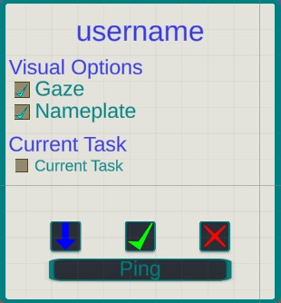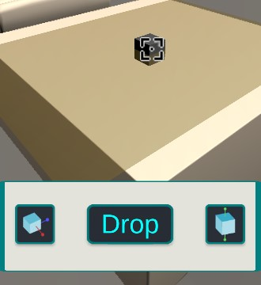

Figure 28 Selection Menu for Participants (left) and Play Models (right)

Initially the visual design for the functionality focused on the single objective of pointing an object in the digital space. The idea behind this decision was that students would prefer a subtle and simple visual feedback that minimized distractions and possible disruptions to their work. Curiously, upon testing the functionality in the classroom, they found that the idea of pointing or calling attention to an object or participant was not as useful as initially though, or more specifically, was the least useful idea that was coming to mind. Students started to propose a wider selection of option for visual markers that could be used in different scenarios, not just pointing. Students proposed scenarios like approving and idea, giving feedback in a conversation, asking for the removal of an element or helping to convey a decision taken. Figure 29 shows some of the options added to the “ping” command, that was now treated as an option to add a visual reaction linked to an object or a participant. The idea was to offer options for highlighting an object, confirming and denying something, this, based on the recommendation given by students for different types of interactions and situations.

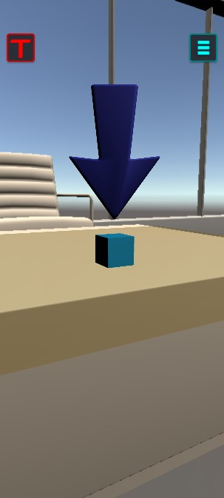

Figure 29 Different options added to the pointing interaction

Pointing at an object in the physical space presented a different challenge. The main issue was related to not having a digital anchor that could reliably hold the pointing visualization, like the user anchor or the play models themselves. For a physical object, the pointer had to be positioned in relation to the shared origin of the Room and the perceived position of the object by the participant doing the pointing. Two options were proposed to achieve this behaviour with the proposed architecture present in WorkshopAR:

* Expand the plane detection to identify as many surfaces in the room as possible, creating a set of invisible anchors that could be used to hold the pointer as close as possible to the point in real space.
* Use the AR Raycast to estimate a distance to the point in space where the visualization should be added, based on the visual feedback of the participant’s camera.

Since the students preferred the tools to point at the play models rather than to objects in the real space, it was possible to experiment a little wit both approaches without fully committing to a definite implementation to show to the students. Figure 30 shows examples of the mock-ups implemented for both scenarios.

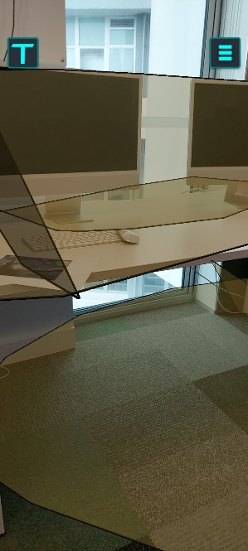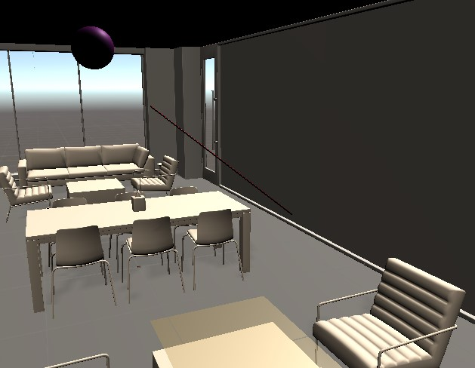

Figure 30 General Plane Detection and Raycast Estimation tools

Expanding the plane detection offered the most precision art the cost of configuration time. It would be possible to ask the host to spend more time scanning more elements of the room to create this “holders” which could be turned on and off when positioning a pointer in space (or other digital objects, like annotations. The plane detection could also be turned on for every client connecting to the room, distributing the responsibility among all participants and helping to refine the detection of features in the room using shared information across the network (citation). In either case, the implementations add a more complex layer of configuration to the room, an effectively trivializes the existence of the workspace, which was though as a simplification of the process to begin with. This idea can be refined and expanded in future work, focusing on the idea of a shared scan of the environment to off-load configuration responsibilities and time.

The raycast option offered a simpler development as well as a simple interaction process for the users. The problem with this approach is impression, mainly because the local position of each device in the shared room is not completely synchronized. Not only each visualization is based on the position of the target image, which is impossible to completely reproduce in every scan, but also the colocalization process always creates a noticeable drift of the visualization over time, especially if a direct visual to the target image is lost for too long. The drifting and the differences in points of view causes that every digital object looks “off-place”’

The users again came up with an interesting solution for this scenario using the tools at their disposal. They resolved to point at thing, digital or physical, using the gaze of the user anchor. Since the anchor follows the position and orientation of the device, it was easy for the users to position the anchor in relation to what they wanted to pint at. Other participant would look at the user anchor through their own devices pointing with the gaze at the object in question. To accommodate this behaviour, a simple tool was developed to extend the gaze of the anchor as shown in Figure 31 to use it as a digital telescopic pointer. In coordination with the ping animations added, it was possible for the students to point at different entities in the room and even convey an array of meanings that were not considered in the initial design.

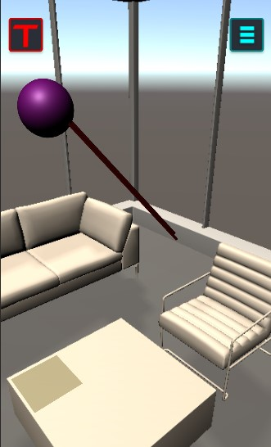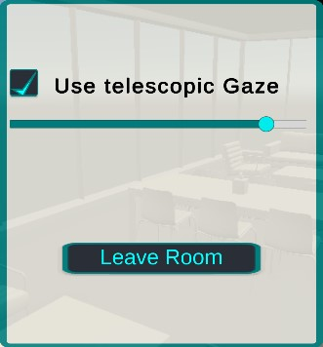

Figure 31 Visuals and controls for the telescopic gaze used for pointing

### 5.2.3.2 Interacting with Play Models

It was observed during the first test iteration that students were interested in the possible interactions that could be achieved with the play models and how the tool could be used in different types of activities. It was also important to consider that the observation stage would start to take place during the bulk of the work in the Industry Project assignments, were the most amount of design work was going to take place and were the tool could be proven to be most useful.

To provide an interesting set of interactions, the development focused on three main objectives related to this functionality and supported by the comments and ideas gathered from students and other tests subjects:

* A varied set of shapes that could be adapted to diverse scenarios and ideas.
* The ability to stack and snap models together to create more complex structures.
* A quick an easy interaction using the touch screen or simple movements of the device.

Figure 32 shows the simple set of basic models that was added to offer the students different possibilities to express their ideas. In relation to this functionality, the possibility of adding to WorkshopAR a visualization of any model build in externals tools was discussed with the students. Although some of them expressed interest in the possibility of interacting with such a functionality, there were also a lot of against the idea, or more specifically, against the need of using such a tool. For instance, the diversity of profiles in the backgrounds of the students conforming each group meant that only one or two team members had a background in architectural or construction engineering, and sometimes there were not at all, being shared with other groups. This caused that not many students were confident or interested in directly manipulating or interacting with architectural models, preferring more high-level discussions or using tools they felt more familiar with. To facilitating the overall development of the tools and focusing on as many student profiles as possible, it was decided that the implementation using the base play models was enough.

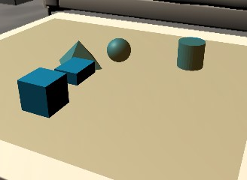

Figure 32 Available Play Models

The interaction itself with the models evolved from the tools implemented for the configuration of the workspace, as well as incorporating the feedback obtained around that functionality. In this new version of the controls, the movement of each model was linked to a point in the centre of the camera and would follow any movement detected in the device. This cause for some user to feel frustration at finding that the touch screen was not part of the interaction, expecting some form of response from those controls. Additionally, when presented with a big enough workspace, users had to constantly move a adjust their position to obtain the desired results. To solve this problem, an additional control point was added to the touch screen, where a widget would show the user what interaction where possible when dragging the cursor in a particular direction of the screen. The cursor would also act as the centre point from which the Raycast Manager would work, allowing for the movement of the camera to keep working as a mean to move the play models, allowing several ways for the user to fine tune their positioning and selection. These same controls were extended to the workspace configuration, where the issues were initially identified. Figure 33 shows examples of the visual elements for these controls.

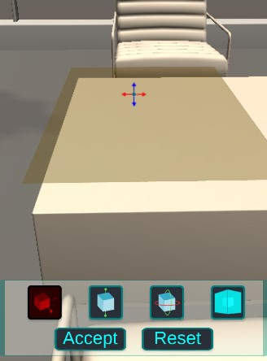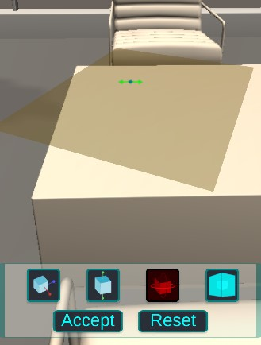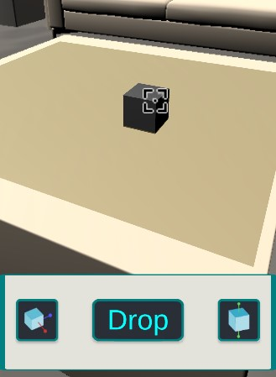

Figure 1 Control tools for the position (left) and rotation (centre) of the workspace as well as the positioning of the play models (right)

Parallel to the interaction design for each user to move and position the play models, it was necessary to design and implement a proper protocol to control several participants interacting with a single model over the network.

The architectural design stablished the network authority for each play model to the client that initially spawned the model in the room. The final implementation simply expended that design to coordinate the transference of ownership whenever some other participant wishes to interact with a play model. Since the prototype of WorkshopAR shown to the students did not contemplate any form of persistence of the session, keeping track of the ownership of models was unnecessary.

The whole process is transparent to the users, and by design the participants have no awareness of the ownership they may or not have of a model, since the idea is that the workspace should be considered as a public zone for shared resources. Nonetheless, it was important to convey the idea that someone else is interacting with a given model, enforcing an external protocol to organize the interactions between participants and relying on physical communication and external teamwork. Figure 34 shows examples of the visual elements that enforce the organized interaction with the play models.

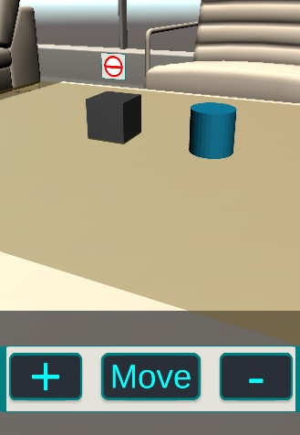

Figure 34 Visual Elements that enforce the shared interaction protocol

Finally, it can be interesting to mention at this point the discarded functionality of the personal workspace. Section 5.1.1.1 explains the logic behind the selected task to analyse, not only in terms of what could be of relevance to analyse natural gestures in AR, but also what tasks could be expected to be implemented in a collaborative AR application. Through the analysis of the literature the idea of distinguishing between a shared and a personal space surged as a possible idea that needed to be conveyed graphically and through the interaction design.

From the data gathered from the participants, it was determined that the users did not find such a distinction useful or crucial, and found the possibility of having a private interaction during the groups gathering as troublesome instead. As an alternative to a full development that could be better focused in other functionalities, it was decided that one of the focuses of the observations would be to identify if any situation of behaviour would justify the implementation of a private workspace. Details of the observations done with the students can be found in chapter 6, but it is important to mention that none of the observation gathered truly related to this topic in a strong sense, at least in the immediate context of the work done for the Industry Project course.

### 5.2.3.3 Annotations

The idea behind annotations was to offer the students the ability to record information in written text and to possibly “attach” that knowledge or ideas to elements in the room, creating relationships between concepts, conveying new meaning or using the physical space as another resource to work with.

In contrast to the play models, the annotations are not limited to the workspace, and can be placed freely anywhere in the room, which necessitated a solution similar to that of pointing objects in the space to position the annotation, taking into account all the considerations and challenges related to low accuracy and changes in points of view discussed in section 5.2.3.1

A special consideration derived from the decision of allowing any positioning for the annotations. Both during the design analysis and in data gathered from the students the concern of creating too much visual clutter in the room was mentioned, either by accident or maliciously. Two tools were constructed with the purpose of giving the students some control over the situation, by allowing to hide some or all of the annotations and by allowing each user to disable the visual an animation flare created for the digital objects associated to the annotations. Figure 35 shows examples of the localization and control mechanics create for this functionality. In the end, as with other tools like the pointing mechanics, it is possible to create a hindrance or a distraction if misused. Some considerations were taken to allow the users to manage what is been shown in the local device, but it is important to consider that no amount of control is infallible, and proper team management and digital etiquette (citation) is always the best policy.

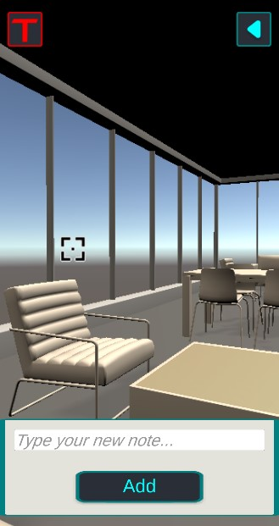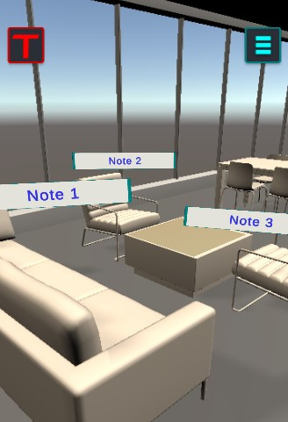

Figure 35 Controls for adding and managing annotations

For the implementation shown to the students only text annotation was considered. Although images that could be used as annotations was compatible with the current implementation, there was not an easy solution to offer the students the ability to create or add meaningful images, in contrast of how simple was to create meaningful text. A simple solution that was prototyped but not tested due to time constraints was to use the image and camera utilities of the device to act as a source of images. The emote functionality was also expanded to the annotation feature as will be shown in the next section.

### 5.2.3.4 Debates and Emotes

The final functionality implemented that picked the interest of the users as identified during the test phase was the tool to manage discussions and voting processes. It was also the functionality that changed the most from the design phase in response form the comments and ideas collected from the users.

In the original design, and interface was presented to the students with information about the vote question or premise and the possible options to select. The structure and organization of the team around the discussion was left to the students to execute with the amount of structure they wished to implement.

This proposal prompted two set of opposing opinions among the students. Some users questioned the necessity to interact at all with the application to organize the debate, highlighting how disruptive the idea sounded for the communication between participants. In contrasts, others found the idea of interacting with visuals that conveyed more information about the activity as useful and a way to “spice” the conversation and help make the activity ore interesting. It was clear that the mechanic was divisive at best, so it was important to find a common middle grand between the two views, that could highlight the positive aspects of the activity while mitigating the negative observations.

Three elements were identified as the core of the experience and that could provide the most advantages in any scenario or usage of the tool:

* Signal to the participants that an activity involving the whole group was necessary.
* Quickly check information about the discussion topic and the possible answers or options, if any.
* Quickly check the answers provided or the positions taken by each participant.

Alternatively, the most concerning aspects of the use case related to forcing the participants to interact with a digital interface where a quick face-to-face discussion was possible, and probably creating a hindrance to communication by limiting answers to what was configured in the application. Forcing a strict structure to the debate process also concerned some users that could see such process as something that would make any activity with the group take longer or be prone to mistakes and delays.

The final implementation offered the possibility to approach the debate process with two degrees of structure. The loosest version of the activity would act only as a general call to all participants in the room to pay attention to the team member that initiate the activity. The only UI element present would be that notification that a debate was in progress and who started it. Elements like the subject of debate, possible answers and the voting process itself was the group’s responsibility and outside the flow of the app.

The second level of structures offered to the person initiating the activity the possibility to configure a topic and add voting options if so desired. The UI then would show this information to each participant, as shown in Figure 36. More configuration points for the structure of the activity were considered, like forcing participants to vote and allowing for a flow of question-response activity to take place, but only the first two levels were implemented and shown to the students, while some other options were discussed.

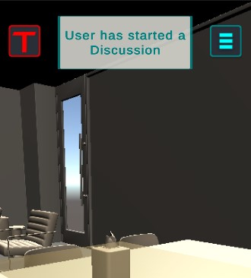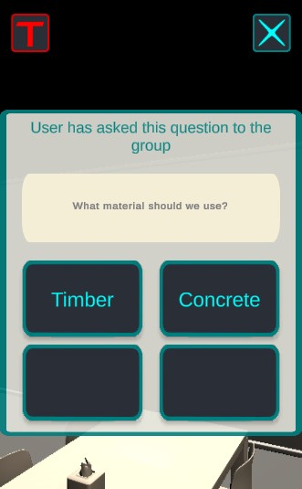

Figure 36 Discussion Tool Interface for the first (left) and second (right) level of structure

Interaction with the UI, especially during the voting process, was completely changed to avoid the major critique of forcing interaction with the device for an activity meant for face-to-face communication. Combining the ideas acquired from different users, a system of emotes was implemented linked to the visualization of the User Anchor, which was closer linked to the position of the device and to the person controlling it. The emotes would show a visual that could represent several meanings from a selection implemented in the app. The emotes implemented represented simple affirmations or negatives, as well as set of possible answers or postures using the letters A, B, C, D and a set of colours. Figure 37 shows examples of some of the emotes implemented.

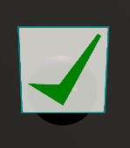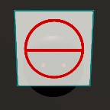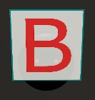

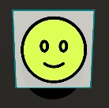

Figure 37 Emotes created for the discussion tool

The solution was not perfect but emphasized the priorities and the development goals of WorkshopAR, using visual to augment the collaborative process without undermining the value and need of communication. It is also the most prominent example of the user-driven design of the tool, and of the importance of incorporating the final user early in the design stage, to align the needs of the users with the objectives of the development and to understand the ramifications of a decision in the learning background where the tool is going to be implemented.

## 5.2.4 Analysis of the Second Iteration

The final evaluation process of WorkshopAR tried to focus primarily in the new functionalities shown to the students but also was intended as a post-mortem of the development process as a whole and its impact on the overall learning intervention and research goals.

### 5.2.4.1 Implementation and analysis of the Use Cases

The implementation of the second iteration focused on fleshing out the use cases identified as most relevant during the design phase. In general, users orbited the most around the interactions with the play models and the emote features present in the debate tool.

The pointing and debate feature where the ones that changed the most based on feedback and input form the users, incorporating interactions and visuals proposed by the students themselves as a direct result of the interaction with the scenarios proposed by the tool.

The feedback loop implemented during both instances of testing proved invaluable to understand the real context in which the application was being used, the problems found by the users naturally interacting with the software and the workarounds they found. In was also and important step of the observation phase, creating opportunities to analyse the behaviours promoted by the tool, to take notes of positive or interesting developments to work upon and identify instances in which was necessary a course correction. A good example of this process in the pointing feature in general, which initially was designed as a tool to avoid ambiguity in the 3D space layered with digital information. Users found this intended purpose unnecessary, defaulting to direct communication with their peers as an easier and more effective way of clarifying any doubt. Yet, they realized that the visualizations using for pointing could be used to convey more meanings such as affirmations, validation of ideas or emotional context to whatever was the topic of conversation. Using visual elements to convey extra meaning was like the use of emotes in others forms of media and communication (citation). When given that connotation, users started to incorporate the tool more on their normal conversation, eventually transferring the feature to the debate functionality as they preferred form to transmit information to other participants coated with an extra layer of emotional meaning.

An important amount of development time was invested on creating a consistent positioning of digital objects in the room, with mixed results obtained. A combination of the image tracking colocalization technique and the natural drift present in AR visualizations caused several issues with the overall visualization in each user’s device, which often made the users re-scan the target image or even forcing them to exit and re-enter the room to reset the visualization. The problems observed were not experience-breaking and completely expected, hence the tools to reset the whole visualization. Nonetheless, these issues represented a common focus of malcontent and an important aspect of the project to work upon in future research, adapting different techniques to work with drifting ad positioning issues such as the ones proposed by (citation). It could be of interest to explores these solutions in a shared scenario, specially one with the characterises observed in the case study, where the point of view of the users was constantly moving and the application was not in constant focus on the device.

The second biggest tweak of the initial design is strongly related to this situation, since explain why the application was constantly losing focus on the device. Users needed to concentrate in other aspects of their work not related to the application, moving to other apps or other devices like their laptops, or simply taking a break from the activity. Several students also mentioned not feeling comfortable constantly being aware of their phones to participate in the activity, preferring and finding more productive jumping form their pc to a direct conversation with ease, without having to set-up WorkshopAR all over again.

This was considered as a major behavioural issue, more suited to be accounted for in the learning design, as will be explored in chapter 6. An approach to deal with the situation through the interaction design attempted to give the students the opportunity to keep their devices in a more stable and fixed position using articulated clamp arms, as shown in figure 38. This setup allowed the students to user their devices as a second screen while they were working, with their laptops being the device assigned to production and the smartphone rig as a tool for communication and the centre for the shared experience of the group.

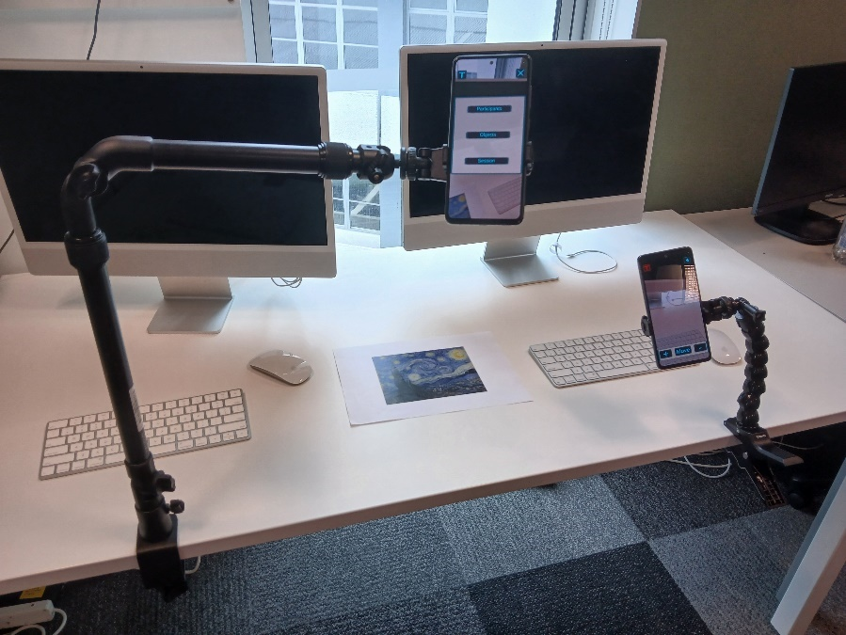

Figure 38 Setup with rig arms

The idea was to find a middle point between a complete free-range use of the device and a more structured and controlled one, but it was still far from perfect. In first instance, in ran against the flexibility goals proposed for the design of the tool since int forced the group to have access to tables to use as a support for the arms, as well as having the arms themselves or structures that could work like the arms. The situation undermined the idea that WorkshopAR could augment any space to help with a work session.

Table 4 codes the most important comments and observations gathered from the students around the rigged arms arrangement. Positive outlooks highlighted the “professional” look of the setting, which resembled a control centre or a dashboard. Some other students compared it to the setup that some streamers use while creating content, indicating that the setting does gives the idea of a social activity.

Negative views on the other hand mentioned how cumbersome the arms could get, restricting freedom of movement and forcing the device to be part of this single activity. More important, the setting did not fully address the concern of many students that WorkshopAR was giving too much emphasis to the phone, giving it too much of a spotlight and easy access to it, when the focus should be on the conversation or the work being done by the students.

Table 4

Although bumped by several technical difficulties, which are common in this type of developments, the final round of implementation can be considered a success. It was not only possible and prototype and test all the use cases proposed, it was possible to perform substantial iterations over the original design informed by the needs of the context, the deviations observed from the learning goals and the genuine interest of the students, who provided valuable insights thanks to their inclusions in the process and the value they were able to perceive in the inclusion of the tool to their workflow.

### 5.2.4.2 Analysis of the overall development

The development of WorkshopAR was contextualized by the exploratory needs of the research, and the process was always aiming for flexibility and adaptability, as well as framing the whole activity as an exercise in user-driven design, which was identified as an useful process to integrate the software development with the tasks of learning design at the core of the research.

Chapter 4 outlined two main objectives specifically concerned with the technological development of WorkshopAR (see section 4.1.3). The first goal was to provide a networking framework that allowed the students to configure a shared experience and create a sense of connection to the digital space to be use for the activity. Analysing the data obtained and observations of the activities performed by the students, it is possible to conclude that WorkshopAR successfully created such an experience, specifically in distinguishable fronts like the contextualization that the students gave to the tool, related to the social aspects of their work, and how they adapted what they considered the most relevant functionalities of WorkshopAR in a way that worked the most for them.

A first positive highlight is related to the room. The idea of both creating and joining to the Room established in the students the sense of space needed to work, as well as allowing for a connection between the members of the group sharing the activity and working towards the same purpose and not only assisting class at the same time.

What initially was considered the most appealing elements of the room: the play models and the annotations, resulted not as interesting for the students as expected, although in the different instances in which the tool was shown to the users they engaged with the functionalities and provided valuable information, interest did not go too far from that. One of the main reasons was the nature of the work the students were doing for the course, more related to quick chats with their teammates and with the production of written materials. Ideas and interactions over the concept of the room were plentiful, highlighting elements about the different media that could be added to the room to extend its functionality, the ability to save and recreate the state of the room to reuse it later and even comparing the tool in general with a 3D repository of information generated by the group. A more tangible version of a shared folder like Dropbox or OneDrive.

Other comparison shared mentioned software like Zoom, Discord or Teams. This is important because shows that the used were understanding the Room as a space for connection, communications and shared resources, part of the intended design. It also highlights the social and collaborative elements at the core of WorkshopAR, and the general design goal of “augmented collaboration”.

The technical difficulties encountered during the development of the networking infrastructure also highlighted one of the most contentious aspects in the implementation of AR technologies when put into the conditions that can be found in a classroom. A strong argument can be made, based on the observations gathered and the record of similar results in the literature (see section 2), that one of the major obstacles of educational AR is the lack of stability. The technology tends to fail, its quality depends strongly on the capabilities of the devices at hand and is easy for the users to find point of stress in the usage of any tool, which immediately affects the flow of the learning experience. Another telling example for this argument is that the most successful implementations of AR found in the literature were related to medical learning and the chirurgical practice, and were projects characterized by very tailored technology, often build from the ground up to fulfil the specific learning goal at hand.

An important challenge for implementing any technology in the classroom is offsetting all the extra elements injected by the technology (configurations, accessibility, learning curves, points of failure) with the tangible benefits in the fulfilling of the learning goal. In analysing and evaluating the impact of the prototype built, I can propose that the following element linked to the use of AR at the core of the software offered the most positive influence and promoted desirable and interesting behaviours in the students:

* The opportunity to discuss the level of structure to implement for the interactions in the group and to have visual elements that identify that structure and allows interactions with it.
* To add layers of meaning to different elements and resources of the collaboration, such as the physical space, the resources at hand and the communication process taking place.

These observations create a contrast with the original hypothesis proposed, where the interaction with the digital objects and the use of strong visuals in the augmentation were proposed as the most important drivers of the tool. The evidence shows that the students did not rely much on the functionalities like the play models or the annotations but were drawn by most simple and practical features like the emotes and the user anchors. These features were also characterized by offering the capacity for expression and choice.

The second goal proposed for the technical aspect of the research was to create a multiplatform experience that highlighted and enabled flexibility in terms of the hardware needed to implement the experience on the classroom, to offer increased accessibility and to align to a BYOD philosophy of TEL.

In terms of development, the tools at disposal in the current market and development environment offer an amazing opportunity to fulfil this objective almost to a 100%. It is possible to confirm that WorkshopAR covers a wide range of mobile devices with a single code base and can cover several more distinct devices with few adaptations.

The interaction design process followed to support the multiplatform objective was also successful, and the user-driven approach proved indispensable to obtain quick feedback and promote a development with constant iteration and adaptability, as mentioned several times previously. An interesting follow up to this line of research would be to offer flexibility on the interaction design and not only consistency, by coordinating the interaction with different types of input devices.

But the multiplatform design was not without its issues when tested against the real context of the implementation, and it managed to both overshoot and underperform in the eyes of the students.

Although the students felt compelled for an experience using AR to explore and learn different concepts in their professions, a strong reticence was found to the idea of relying entirely on the technology to complete their academical work. Table 5 shows the most prominent responses given by the students when asked to explain their view on the tools needed for their work. The responses aligned with previous observations of students feeling negative around the idea of constantly using the phone during the activity in class. The idea of working in the classroom while wearing a headset like the Meta Quest or the HoloLens was out of the question, at least not “with the current bulky technology” as commented by one student.

Table 5

On the other hand, the design of WorkshopAR failed to recognize the constant need of the students to jump in between applications and devices. The most important tool for work during the classroom session was their laptops or work tablets, and WorkshopAR failed to acknowledge any other device as part of the experience, which caused the student to feel WorkshopAR as detached from the workflow. An important lesson here, worthy of further exploration and expansion, is that supporting collaboration between people also means supporting collaboration between tools, or the support won’t feel complete (citation).

### 5.2.4.3 Implications for the research goals

At the beginning of the architectural design exercise, it was identified that the technological development of WorkshopAR would provide interesting information to build a final answer for research questions SQ5 and SQ6.

Previous sections already illustrated how creating choice and flexibility in the interaction design allowed for a higher impact in the user experience that simply offering a straightforward interaction with the visualizations. Giving the users the opportunity to create their own sense of meaning and venues for expression gave to WorkshopAR a higher sense of social relevance that the other tools created to manage or visualize the team.

Given these observations, it is possible to identify key elements that can be used to build the final answer for the related research questions.

For question SQ5, visualization and flexibility were identified as the main advantages provided by AR technologies that can be used in learning environments and create a significant impact in the student’s experience. In terms of the visualization features that AR can provide, it was possible to observe that the students showed preferences to unintrusive visuals that could be approached only hen desired and that could be used in different purposes, conveying meaning and utility based on the context without getting in the way of the work to be done. These observations are relevant considering the context of the case study, and could be extrapolated to any TEL intervention where it is important to consider that the learning activity and not the tool should be the centre of attention. For a tool focused on helping with collaborative work, it makes sense that the students would prefer for the tool to work as unnoticed as possible, providing aid and not hindrance. It is a difficult balance to achieve that requires disciplined analysis of the feedback and a consistent iterative development.

The idea behind what type of flexibility could be offered by WorkshopAR was also expanded from just elements about the platforms used for deployment to the resources being used by the students and the structure used for the interaction experience. The idea of flexibility guided the design when proposing the play model tools and the overall motivation of transforming any space into a working space. It was observed that it could permeate even more elements of the design, and the processes proposed to the students to fulfil different goals, especially those related to organize the team, organize discussions and communicate ideas through the app, where to rigidly structured. This proposed structure was welcome by some, those having problems organizing the group or needing and explicit guideline for their work, but resented by more organized or veteran students, who felt the app as to restrictive. This hints at a need for flexibility, and the need to propose and structure, but allowing for workarounds and configuration’ A similar situation is present when the students found ways of customizing their presence in the digital space and finding tools to create tailored forms of communication, which were initially considered but not given the importance they finally acquired.

Observations of the most important aspects that evolved from the initial conception for strong visualizations and a flexible approach resonate very well with the educational nature of the tool: Useful visuals that do not still the focus from the learning goal and a flexible structure that accommodates the different types of learners that could interact with the application.

Question SQ6 is more concerned with the opportunities created by a multiuser platform for education, and the effect of mediating communication by technology. Creating a mostly transparent networking process was helpful to ensure that the friction created by the introduction of the tool was minimized as much as possible, giving extra strength to the idea that any technological intervention works the best when it is as invisible as possible. It was also possible to identify early when the usage of the tool itself was promoting social structures that were not desired (the responsibilities of the host user), and redesign the approach so that any social structure, goal or task assigned to any participant came from the own team management process and supported by the tool, not enforced by it.

A final important lesson related to the multiuser approach was to not underestimate the importance of the social aspects present in any form of collaborative learning. It was possible to identify that there is an overfocus on promoting management and organizational skills through the pedagogical design of the activities, sometimes on detriment on promoting equally important skills related to socialization, communication and emotional management. This is true for both the design of WorkshopAR, that found the most success among the students when presenting interesting forms of communication on top of the team management tools, and the case study in general, in which the students struggled the most with the social and communications aspects of the project rather than the technical ones.

# 5.3 Conclusions

WorkshopAR was the result of an iterative software development aimed at understanding positive ways of using AR technologies as a driver for a collaborative learning approach. The end result was a prototype that enabled the users the ability to integrate into the workflow of their projects a tool that helped them to visualize all the components in motion needed for an effective teamwork and to actively participate in the procedures that make such work possible, and that sometimes are executed unconsciously and without acknowledgment of their functionality in the group, on the improvements that could take place for better results in the future and of the possibility of transferring the skills being developed into other scenarios.

Coming from an exhaustive design stage that identified several use case scenarios in which the students used the tools provided by WorkshopAR in their learning activities, and by constantly comparing the prototyped functionalities against the observations obtained during the different structured tests and informal observations that took place during the development cycle, it is possible to highlight the three main elements provided by WorkshopAR that better align with the learning goals of the case study and that proved to generate the most value for the research context in which the development took place:

* Working in a Shared AR Room: Although immersion was not a main design objective for WorkshopAR, it was important for the students to identify that the activities done using the tool moved in a digital space that was in sync with their activities in the real space. The concept of the Room was related to de idea of a space for working, entering the Room was equivalent to be part of the activity and the Room was seen as a repository for digital content. But the Room also existed alongside the other tools and resources being use in the classroom (the workshops of the course, their teaching assistants, the students of other groups, etc.) and they were able to propose ways to integrate all of these elements in order to achieve the desired results.

All of these observations aligned very well with the original intention of the design and support the idea that “a sense of immersion” in the context of AR technologies include the physical space and include elements and activities outside the tool itself, and that can be used very effectively to fulfil a varied spectrum of objectives. In the context of this research, it means that this take on immersive design that AR allows can create and advantage when it is important that the learners do not lose focus of the context in which they are learning, and of all the other elements around them that are also helping them towards achieving their learning goal.

* Having a digital presence in the digital space: AR is a tool that works around visualization and interaction. There was an important effort in the design and implementation process to create different options that capitalized on these advantages provided by WorkshopAR. The students resonated the most with the possibility of having a visual representation of themselves in the digital space, not only for personalization and general socialization, but as a point for interaction with their peers and the environment. Being able to see information about who is who and the tasks being performed created the biggest sense of “augmentation” of the activity and the biggest source of opportunities to work in the future.
* Having visual and flexible tools for communication: In a similar note, the tools provided for communication create a lot of impact in the activities of the students. The main takeaway from the observation related to these tools (discussions, emotes, pointers) is about flexibility and expression. The elements provided for communication were simple, expandable and context-independent, which gave the students to use them in diverse scenarios and adapt them to their needs and preferences, highlighting the social nature of the application and an important avenue for future research.

The original set of hypotheses created during the design stage of WorkshopAR gave more emphasis to the interaction with play models and with the structure tools to manage the team as the focal interactions that would drive the activities the most. It was clearly not the case, but it is curious that those activities emphasized the same high-level aspects of the experience: A rich visual interaction with the environment and access to tools for social interaction.

1. Images extracted from <https://www.youtube.com/watch?v=Exu7r2vZpcw> and <https://www.youtube.com/watch?v=dtp6b76pMak>